**Low-Cost Precision Agriculture Solutions for Advancing Irrigation Efficiency, Project 10-2024**

**Final Report**

Mary Love Tagert, [mltagert@abe.msstate.edu](mailto:mltagert@abe.msstate.edu), 662-325-4617

Joel O. Paz, [jpaz@abe.msstate.edu](mailto:jpaz@abe.msstate.edu), 662-325-4798

Xiaofei Li, [xl278@msstate.edu](mailto:xl278@msstate.edu), 662-325-9426

Himmy Lo, [himmy.lo@msstate.edu](mailto:himmy.lo@msstate.edu), 662-686-9311

**Rationale/Justification for Research**

Variable-rate irrigation (VRI) is the precision agriculture practice of customizing irrigation amounts to different areas of a field based on the unique characteristics of each area. VRI can be used to compensate for and thus minimize problems associated with in-field spatiotemporal variability, especially that of soil moisture. However, the initial and maintenance costs of zone control VRI, where the flow through individual or groups of sprinklers can be adjusted, is often daunting, and the fear of managing these systems discourages farmers from adopting this technology. However, sector control VRI systems are less expensive and easier to operate because only the revolution speed of the center pivot is adjusted, and most late-model center pivots can be programmed to travel at a different speed (and thus apply a different irrigation amount) in each of several pie-shaped sectors without additional control panel upgrades. On fields where the distribution of wetter/drier areas match well with the geometry of pie-shaped sectors, the use of sector control VRI is an ideal solution for advancing irrigation efficiency beyond what is possible with conventional uniform irrigation.

Soil water tension data collected over a production soybean field for the past four years shows the spatiotemporal variability over the field and how sector control VRI may help save water. The northwestern region of the field stays relatively wet when the remainder of the field is dry enough to warrant an irrigation application. The producer has given us permission to implement sector control VRI on this field. Our partnering producer has three more fields under center pivot irrigation, and these fields are much larger with more heterogeneity. We will evaluate one or more of these fields for in-field variability to determine if they may be candidates for sector control VRI, by analyzing soil survey data, surface elevation data, and historical yield data to delineate management zones. Finally, a geospatial inventory of OFWS systems is needed to better quantify the extent of irrigation in this region, direct educational efforts, and justify potential cost assistance programs. Results of the project were shared throughout the year, and progress was made on the following specific objectives:

1. Create and apply a sector control VRI prescription on a production soybean field and measure the water savings realized.
2. Develop a simple method for evaluating whether production fields would benefit from sector control VRI.
3. Evaluate the economic benefit from VRI adoption.
4. Perform a geospatial inventory of surface water storage systems used for irrigation in Northeast Mississippi, to assess the potential for VRI adoption.
5. Share project results with producers and other stakeholders, especially those in Northeast Mississippi.

**Report of Progress by Objective**

**Objective 1: Create and apply a sector control VRI prescription on a production soybean field and measure the water savings realized.**

The VRI prescription used in the previous year was applied on the same production field for the 2024 growing season. A Trimble Yuma GPS was used to locate the centroids of each plot in the field. This year, the producer planted Dekalb DKC62-05 and DKC68-35 corn in this field. Watermark granular matrix soil moisture sensors were installed at the centroids of each plot on May 20th at 12-inch, 24-inch, and 30-inch depths (Fig. 1). All 12 plots in the field have Irrometer Irrocloud IC-10 dataloggers. These dataloggers have a cellular connection that allows the data to be accessed at any time by the producer. The producer irrigated a total of seven times this past growing season, beginning on June 12th and ending on July 18th. When the producer irrigated, each irrigation event applied a full irrigation rate to the full rate plots and a 20% reduction of the full rate to the reduced rate plots (Fig. 2). Soil moisture sensors and data loggers were removed from the field on August 15th prior to harvest. The average soil water tension for sectors under conventional treatments in 2024 was 39 cb, and the average soil water tension for sectors under a reduced treatment was 38 cb (Fig. 3). Yield data from the field was analyzed for the 2022, 2023, and 2024 growing seasons (Fig. 4), and preliminary results show no significant statistical difference between yield under the conventional and reduced irrigation treatments (Table 1).

**Objective 2:** **Develop a simple method for evaluating whether production fields would benefit from sector control VRI.**

Watermark 200ss granular matrix soil moisture sensors were assembled and installed at locations in three fields. Their locations in each field were based on spatial variability of soil type and elevation. The sensor locations in the three larger production fields include three different crops (corn, soybean, and cotton). Field Two was planted in corn this year, and sensors were installed on May 21st at four pre-determined locations and at 12-inch, 24-inch, and 30-inch depths. One of the locations in Field Two has an IC-10 datalogger, while the other three locations have 900M dataloggers. Field Three was planted in soybean, and sensors were installed on May 22nd at five pre-determined locations. Sensors were installed at 12-inch and 24-inch depths. Each location in Field Three has 900M dataloggers. A portion of Field Four was planted in corn, and the sensors were installed on May 21st at two pre-determined locations. Sensors were installed at 12-inch, 24-inch, and 30-inch depths. Originally, both locations had IC-10 dataloggers. After having technical issues with an IC-10 datalogger at one of the locations, a 900M datalogger was substituted on May 23rd. Another portion of Field Four was planted in soybean, and sensors were installed at one pre-determined location at depths of 12 and 24 inches, and this location has a 900M datalogger. Another portion of Field Four was planted in cotton, and the sensors were installed on June 13th at two pre-determined locations at depths of 12 and 24 inches, and both locations have 900M dataloggers. Every week, data from each 900M datalogger in all three fields was downloaded and analyzed. Also, a weighted average of soil moisture tension through the crop rooting zone for each location in corn was calculated, graphed, and shared with the producer each week.

Soil moisture sensors in corn were removed from Field Four on August 15th, and sensors were removed from Field Two on August 16th. Three sensors in Field Three were removed on September 5th, and the other two sensors in Field Three were removed on September 19th. The soil moisture sensors in soybeans in Field Four were removed on September 19th as well, and the Field Four sensors in cotton were removed on October 15th. Soil water tension data from both the 2023 and 2024 growing seasons was analyzed and compared with yield data (Tables 2, 3, and 4). The next goal within Objective 2 is to begin developing a simple guide for producers to implement variable rate irrigation into their operation.

**Objective 3:** **Evaluate the economic benefit from VRI adoption.**

The economic benefit from VRI is primarily from the water savings compared to the conventional uniform irrigation. A source of the economic value of the irrigation water savings comes from pumping energy cost savings. Using the electric pumping cost of $5 per inch, the 44-acre experimental field can save $5 per acre in irrigation cost when reducing its 5-inch irrigation by 20% (2018 data), totaling $220 for the field. Based on the preliminary analysis results of Objective 1, there is no statistically significant yield difference between full and reduced irrigation treatments. Based on these preliminary results, the yield impact of VRI can be safely ignored in the analysis, and the irrigation cost saving can be regarded as the measure of VRI economic benefit.

Because the water source of the experimental field is from the on-farm water storage pond, the total irrigation water amount is limited, and the saved irrigation water by VRI can be used to irrigate more fields on the farm and improve yield. This enlarged irrigation area creates another source of the economic benefit of VRI. The yield increase contribution of irrigation is based on the yield difference between the irrigated and non-irrigated areas of the field. Using 2018 (soybean) data, the yield difference is about 21 bushels per acre, while the irrigated water level is 5 inches. The per acre soybean sale revenue can increase by $21 bushel/acre×\$10.35/bushel=\$217.35/acre$, where the current soybean price of $10.35/bushel is used. By reducing irrigation level by 20%, the irrigated acres can increase by 25%. That means the 44-acre field’s irrigation water savings can be applied to 11 additional irrigated acres and generate an additional $2,390.85 total benefit.

**Objective 4:** **Perform a geospatial inventory of surface water storage systems used for irrigation in Northeast Mississippi, to assess the potential for VRI adoption.**

A geospatial inventory of center pivot irrigation and on-farm water storage (OFWS) systems in Northeast Mississippi for the year 2020 was completed. This geospatial inventory has been compared to United States Department of Agriculture (USDA) Irrigation and Water Management Survey data and Mississippi Department of Environmental Quality (MDEQ) data that details irrigation by each county in Northeast Mississippi. In both inventories, data from 1992-2022 was collected for every five years. The USDA survey collects irrigation acreage by county, and the MDEQ permit data collects irrigation water by volume. The USDA survey data and the MDEQ permit data both show continual increases in irrigation in Northeast Mississippi from 1992-2022. Another geospatial inventory for Northeast Mississippi is being developed to automate the detection of center pivot systems in Northeast Mississippi. National Agriculture Imagery Program (NAIP) imagery from 2023 is being used to develop the automation model.

**Objective 5:** **Share project results with producers and other stakeholders, especially those in Northeast Mississippi.**

1. Dr. Tagert spoke at the North Mississippi Research and Extension Center Field Day on Aug. 22, 2024.
2. AETB graduate student Sam Theobald presented the project’s preliminary findings at the fall Graduate Research Symposium. Sam has communicated with our partnering producer throughout the growing season, sharing our soil moisture data and providing weekly updates.
3. Ag Economics graduate student Gifty Ayela gave a presentation titled ‘Developing Site-Specific Water Response Functions using Historical Soil Moisture Data’ for the Feb. 2025 meeting of the Southern Agricultural Economics Association (SAEA) in Irving, Texas. She also participated in the Three Minute Thesis competition at the SAEA meeting.
4. Sam Theobald presented a poster at the North Mississippi Producer Advisory Council meeting in Verona, Mississippi on February 20, 2025, and the same poster was presented at the Mid-South Farm & Gin Show in Memphis, Tennessee on March 1, 2025.
5. Sam Theobald presented yield maps from the 2023 and 2024 growing season to the producer.

Figure 1. Sam Theobald installing soil moisture sensors.

Figure 2. VRI Map showing wet and dry zones with plots and irrigation rates.

Figure 3. Soil water tension, rainfall, and irrigation totals from the 2024 growing season.

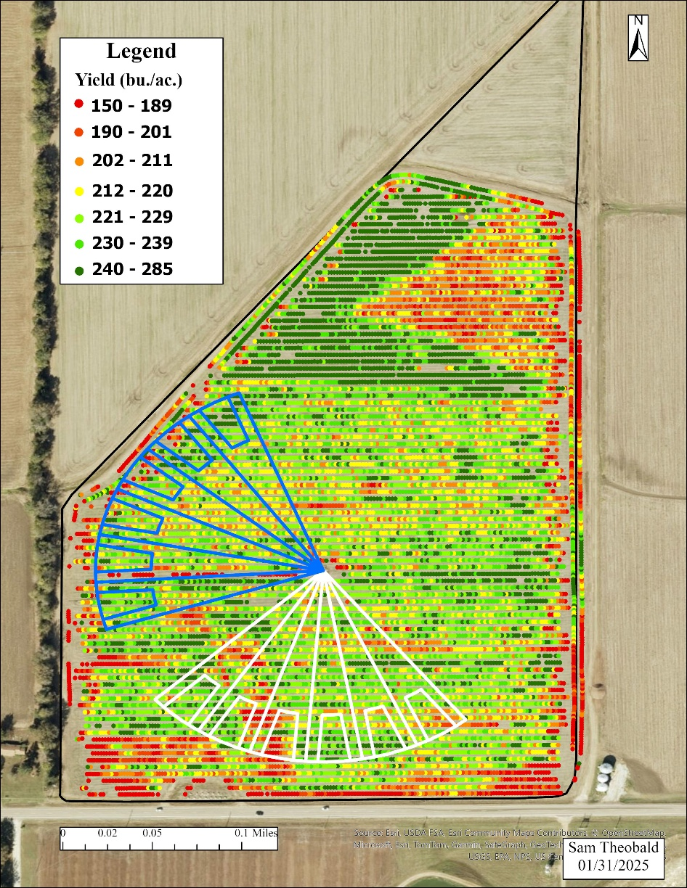

Figure 4. 2024 Yield Map of VRI Field.

Table 1. Average yield by treatment for 2022-2024 Growing Seasons.

Table 2. Field 2 average soil water tension values compared to average yield by management zone.



Table 3. Field 3 average soil water tension values compared to average yield by management zone.

Table 4. Field 4 average soil water tension values compared to average yield by management zone in corn.

Table 5. Changes in Mississippi irrigation from 1992-2022 based on USDA Survey data and MDEQ permit data.

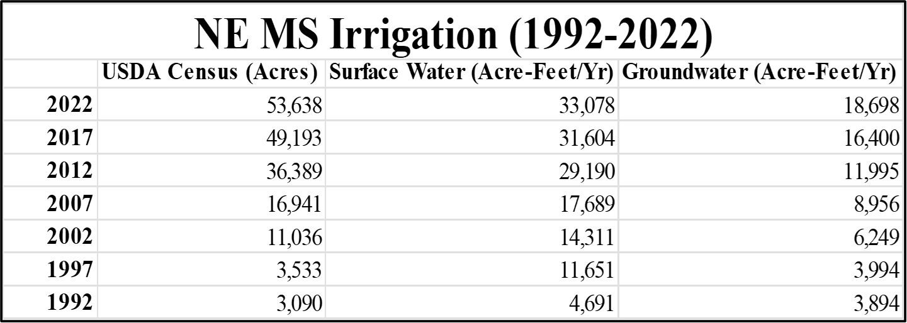



Figure 5. Sam Theobald presenting a poster at the Mid-South Farm & Gin Show in Memphis, TN on March 1, 2025.