**Evaluating fungicide efficacy, desiccant applications, and delayed harvest for soybean grain quality, 14-2024**

**Final Report**

Tessie Wilkerson

662.820.0549

([twilkerson@drec.msstate.edu](mailto:twilkerson@drec.msstate.edu))

**Rationale/Justification for research**

Soybean seed quality has become a growing concern with seed companies and growers. Many variables attribute to seed value after harvest including seed size, vigor, germination and seed health. Pod and stem blight caused by the *Phomopsis/ Diaporthe* complex are one of the most important seed borne diseases affecting the quality of seed and causes more losses in soybean than any other fungal pathogen worldwide. *Phomopsis longicola* Hobbs is the primary cause of seed decay (PSD) in soybean, Glycine max (L.). Previous research indicates *P. longicola* isolate aggressiveness differs between geographic regions and isolates from weeds were more aggressive towards soybean than soybean isolates. Additional research suggests overhead irrigation or rainfed environments produce an increase in *Phomopsis* sp. infection in seed. Soybean growers in the mid-southern U.S. have suffered extreme economic losses from *P. longicola* which can be attributed to the adoption of the early soybean production system. In 2009 0.33 metric tons of soybean were lost to PSD across 16 southern states. Symptoms of this disease include shriveled, elongated seed which appear chalky and have reduce seed germination and emergence. Seed will also have reduced oil content and viability which will incur potential docking at the grain elevator. Seed infection is more severe with early maturing cultivars, when harvest is delayed and environmental conditions continue to be warm and humid during late season and harvest. Current management strategies for this disease include crop rotation with non-hosts, tillage, fungicide applications during pod-fill and resistant cultivars, although these are limited to non-existent. Additional research is needed to determine what other, if any, fungi are contributing to this reduction in seed quality whether it be a single pathogen or relationship between one or more present and methods for management. Further funding will allow continuation of this research towards additional management options for issues surrounding damaged grain.

**Report of Progress/Activity**

**Objective 1:** Evaluate the effect of early and mid-season fungicide application in combination with desiccation on seed quality.

Field experiments were established during 2022-2024. Plots were planted to a DynaGro soybean variety. The experiment was arranged as a randomized complete block with 4 replications. Plots were established as 20 foot by 4 row to assess seed quality with combinations of fungicide and desiccant applications. Plots were sprayed with Miravis Top fungicide starting at R3 (beginning pod) growth stage to simulate an automatic R3-R4 application implemented in many of the southern soybean production systems.

Fungicide and desiccant (Paraquat) applications were made at the appropriate timings (R3, R6, and maturity) each year. Once harvest began, each of the four rows in the plots were harvested individually every 2 weeks to simulate an optimal timing and delayed harvest situations and rated for seed quality on a 0-10 scale with 0=no damage and 10= complete damage to sample. Samples were taken from each plot and stored in cold storage.

**Results**

No significant differences were observed at any harvest timing in regards to plot weights and overall seed quality when compared to the control. Plots weights decreased at each of the four harvest timings. Numerically differences in overall quality were observed between treatments at each of the harvest timings. During harvest #1 which would be the optimal harvest timing there was up to a 38% increase in overall seed quality with a stand alone application of Miravis Top at R6 growth stage when compared to the untreated plots (Table 1). Two weeks later harvest timing #2 provided up to a 40% increase in overall quality with a Miravis Top application applied at R6 alone and a desiccant application at maturity when compared to the nontreated plots as well as up to a 60% increase at harvest # 3 and a 27% increase at harvest #4 which would be 6 weeks post optimal harvest time.

**Discussion**

During 2022-2024 field seasons overall grain quality was at acceptable levels. Some years samples were not able to be collected at specific timings due to weather conditions; therefore some timings may not provide conclusive results. In many cases applications performed equally to the non-treated; therefore, no conclusion can be made surrounding these applications. Combing data across years suggests no significant benefit observed on overall seed quality with fungicide application at R3 or R6 growth stage; however, additional research is needed to determine the effect, if any, of fungicide application with and without desiccation at maturity on seed quality when harvest is delayed.

**Objective 2:** Evaluate desiccation application rates in reducing seed quality in delayed harvest situations.

Field experiments were established during 2022-2024. Plots were planted to a DynaGro soybean variety. The experiment was arranged as a randomized complete block with 4 replications. Plots were established as 20 foot by 4 row to assess seed quality with combinations of fungicide and desiccants at increased rates applications. Plots were sprayed starting at R5.5 growth stage. Fungicide (Miravis Top) and desiccant (Paraquat)applications were made at appropriate timings (R5.5, R6, R6.5, R7) each year. Single rows were harvested with at least 2 weeks between harvests. These timings were used to simulate a delayed harvest situation and to determine the effect of early application and increased rates of desiccants on seed quality. Seed samples were rated for quality on a 0-10 scale with 0=no damage and 10= complete damage to sample. Samples were taken from each plot and stored in cold storage.

**Results**

Significant differences were observed across treatments with regard to growth stage and desiccation rates. According to these results, during 2022-2024, R6 growth stage had the least amount of damage when compared to other growth stages even at the greatest desiccant rates. On average, up to 30% increase in overall damage was observed at the R7 growth stage when compared to R5, R6 and R6.5. With the R7 growth stage up to a 52% increase in damage was observed during harvest # 3 when compared to other harvest timings 1 and 2. The R7 growth stage application seemed to have consistently greater damage when compared to the other growth stages at all three harvest timings, whereas R6 had the least amount of damage on average at each harvest timing. Numerically, on average, up to a 6% increase in damage is observed with the 32 oz rate of desiccant when compared to the 10 and 22 oz rate regardless of harvest timing (Table 2).

**Discussion**

During 2022-2024 overall quality was variable. Some years samples were not able to be collected at specific timings due to weather conditions; therefore, some timings may not provide conclusive results. In some cases applications containing fungicide had less damage than applications with desiccant alone. Data from these trials also suggest increasing rates of desiccants may reduce seed weight. Additional research is needed to determine the effect, if any, of increased rates and timings on seed quality when harvest is delayed.

**Objective 3:** Determine the causal agents of reduced soybean seed quality in harvested soybean seed

Seed harvested from trials in objective 1 and 2 are being processed in the lab to determine fungi present on seed. Seed have been plated on PDA and fungi allowed to grow (Fig. 1). Subcultures of individual fungi were grown to pure culture to acquire DNA for PCR processing/ fungi identification before subjecting to fungicide sensitivity experiments (Fig. 2).

Grain harvested from 2023 field trials was used to isolate fungi present on soybean seed. Fungi were isolated on potato dextrose agar and morphologically identified from pure cultures followed by DNA extraction and PCR for species confirmation. Three isolates were used from each confirmed fungi (*Fusarium incarnatum* (Fig. 3)*,* *Diporthe longicolla*, and *Alternaria alternata* (Fig. 4).

**Results**

***Fusarium incarnatum****:*

On PDA, white to primrose, floccose colony were observed. Conidia were hyaline and septate.

The 650-bp consensus sequence resulted in 100% identity with F. *Incarnatum* GA19C20.1isolate from Georgia, USA.

***Alternaria alternaria***:

On PDA, round, dark olive-green colonies with gray to white aerial mycelia were observed. Conidia were irregular, ovate to obclavate, and light to dark brown in color.

The 540-bp consensus sequence resulted in 100% identity with *A. alternaria* F2_3 isolate from Italy.

***Diporthe longicolla:***

On PDA, dense, white mycelium with floccose texture, along with greenish-yellow areas and black stroma on the colony. Conidiophore were hyaline and septate.

The 300-bp consensus sequence resulted in 100% identity with *D. longicolla* 14-DIA-014 isolate from Serbia.

**Discussion**

Three fungi were identified, namely *Fusarium incarnatum, Diporthe longicolla*, and *Alternaria alternaria*.

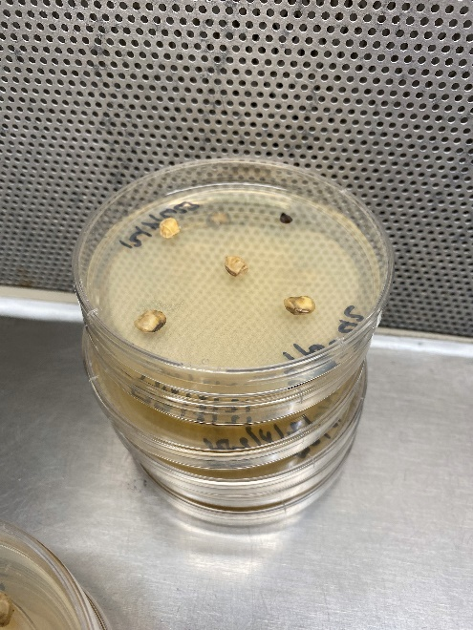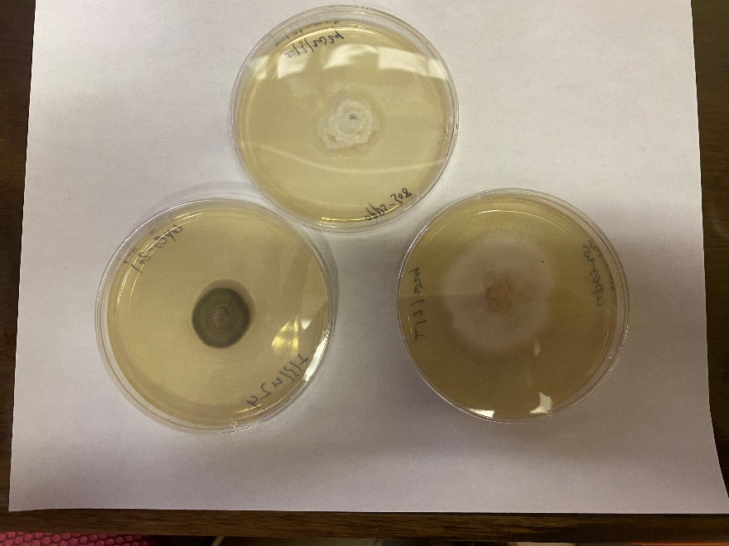

Fig. 2

Fig. 1

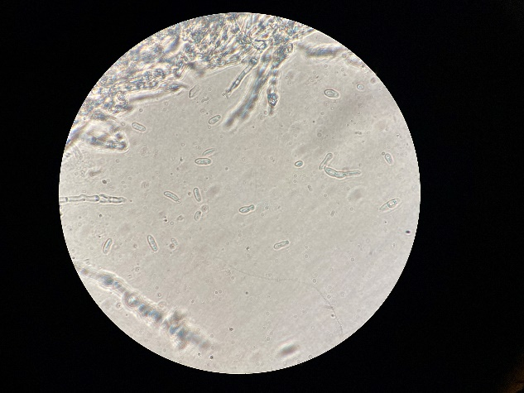 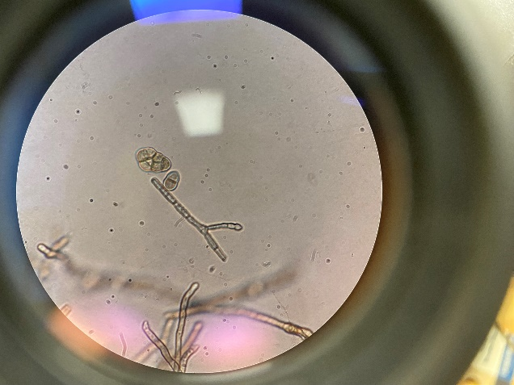

Fig. 3 Fig. 4

**Objective 4:** Determine efficacy of fungicide on reducing growth of pathogen causing seed rot in vitro.

A fungal sensitivity assay was conducted using five fungicides (fluxapyroxad, fluazinam, flutolanil, azoxystrobin, and difenoconazole) at varying concentrations (0 to 0.001 µg/ml) (Fig. 5). A 5mm mycelial plug was placed on fungicide-amended plates, each with three replicates, and incubated at 25°C in darkness. The experiment was arranged in a completely randomized design and repeated 3 times. After 4 days, colony diameter was measured to calculate percentage inhibition. For *F. incarnatum*, the lowest EC50 was observed with azoxystrobin (0.087 µg/ml), while for *D. longicolla* and *A. alternata*, it was with fluazinam (0.001 µg/ml and 0.055 µg/ml, respectively.).

**Results**

***Fusarium incarnatum****:*

No EC50 value was calculated for the fluxapyroxad and flutolanil because all the isolates had percentage inhibition less than 50%.

Significant difference were observed in EC50 for the azoxystrobin, fluazinam, and difenoconazole with EC50 value of 0.09 µg/ml, 0.16 µg/ml, and 0.54 µg/ml respectively.

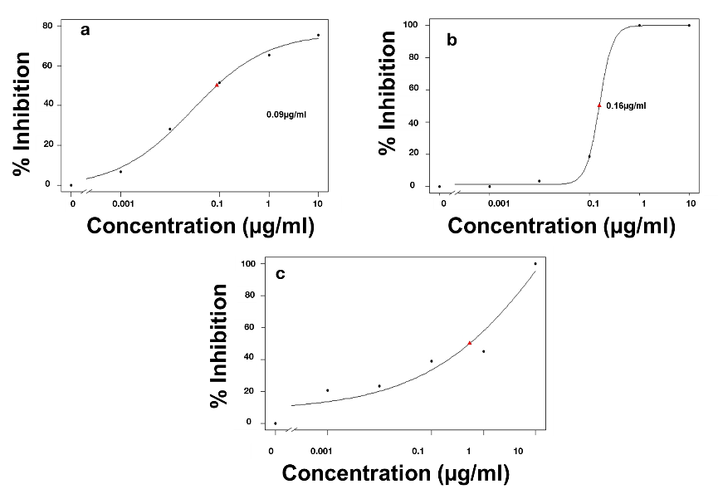

***Alternaria alternaria***:

No EC50 value was calculated for the azoxystrobin and flutolanil because all the isolates had percentage inhibition less than 50%.

Significant difference were observed in average EC50 for the fluazinam (0.06 µg/ml), fluxapyroxad and difenoconazole (both approximately 0.30 µg/ml).

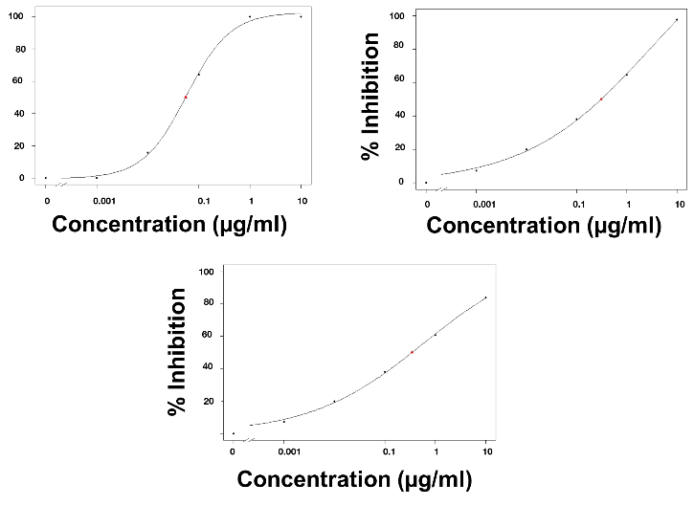

***Diporthe longicolla:***

No EC50 value was calculated for the fungicides azoxystrobin and flutolanil because all the isolates had percentage inhibition less than 50%.

Significant difference were observed in average EC50 for the fungicide fluazinam (0.001 µg/ml), difenoconazole (0.02 µg/ml), and azoxystrobin (0.04 µg/ml).

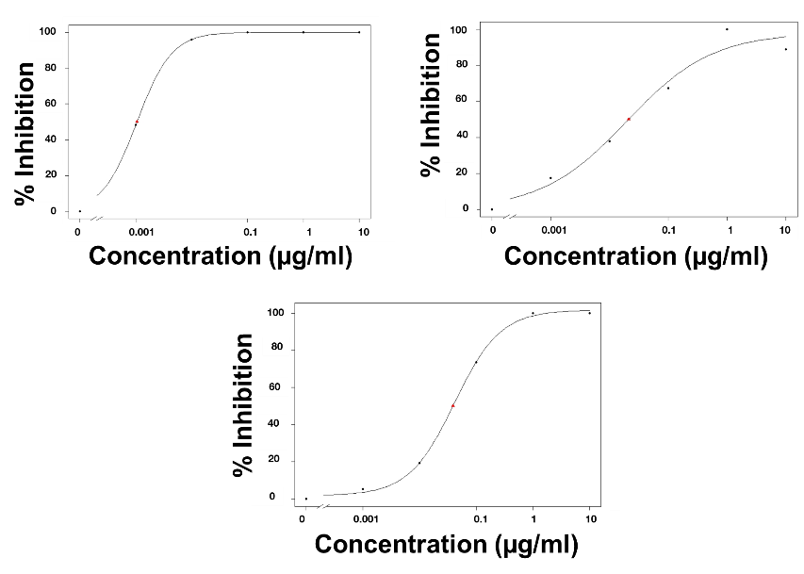

**Discussion**

Significant difference were observed for all the isolate in their EC50 values.

For *F. incarnatum*, the percent mycelium inhibition were less than 50% for fluxapyroxad and flutolanil. However, the isolates showed high sensitivity to azoxystrobin, with EC50 0f 0.08µg/ml.

For *D. longicolla* and *A. Alternaria*, the percent mycelium inhibition were less than 50 % for azoxystrobin and flutolanil. However, isolates were highly sensitive to fluazinam, with EC50 0f 0.001 µg/ml and 0.055 µg/ml, respectively.

Additional research is needed to establish the baseline sensitivity of the isolates obtained from harvested soybean grain.

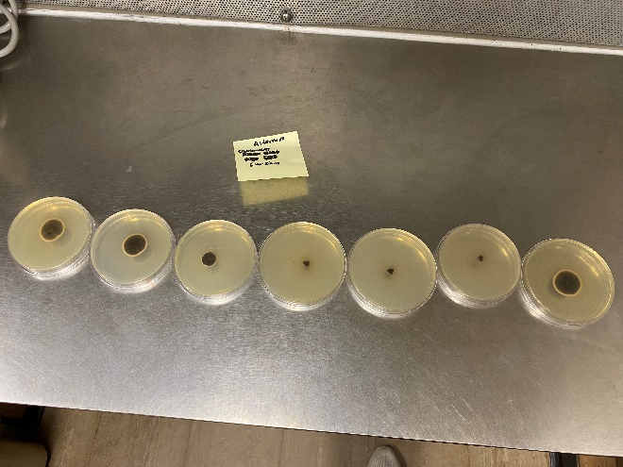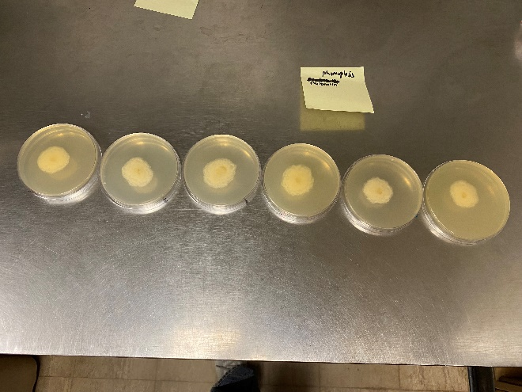

**Impacts and Benefits to Mississippi Soybean Producers**

**Outreach**

Project components have been discussed at board meetings including the Mississippi Soybean Promotion Board summer tour and at the Mid-South Soybean Promotion Board summer and winter meetings.

**End Products–Completed or Forthcoming**

A poster entitled In-vitro fungicide efficacy on fungal isolates recovered from Mississippi soybean seed was presented at the American Phytopathological Society Conference July 27-31, 2024 in Memphis, TN.

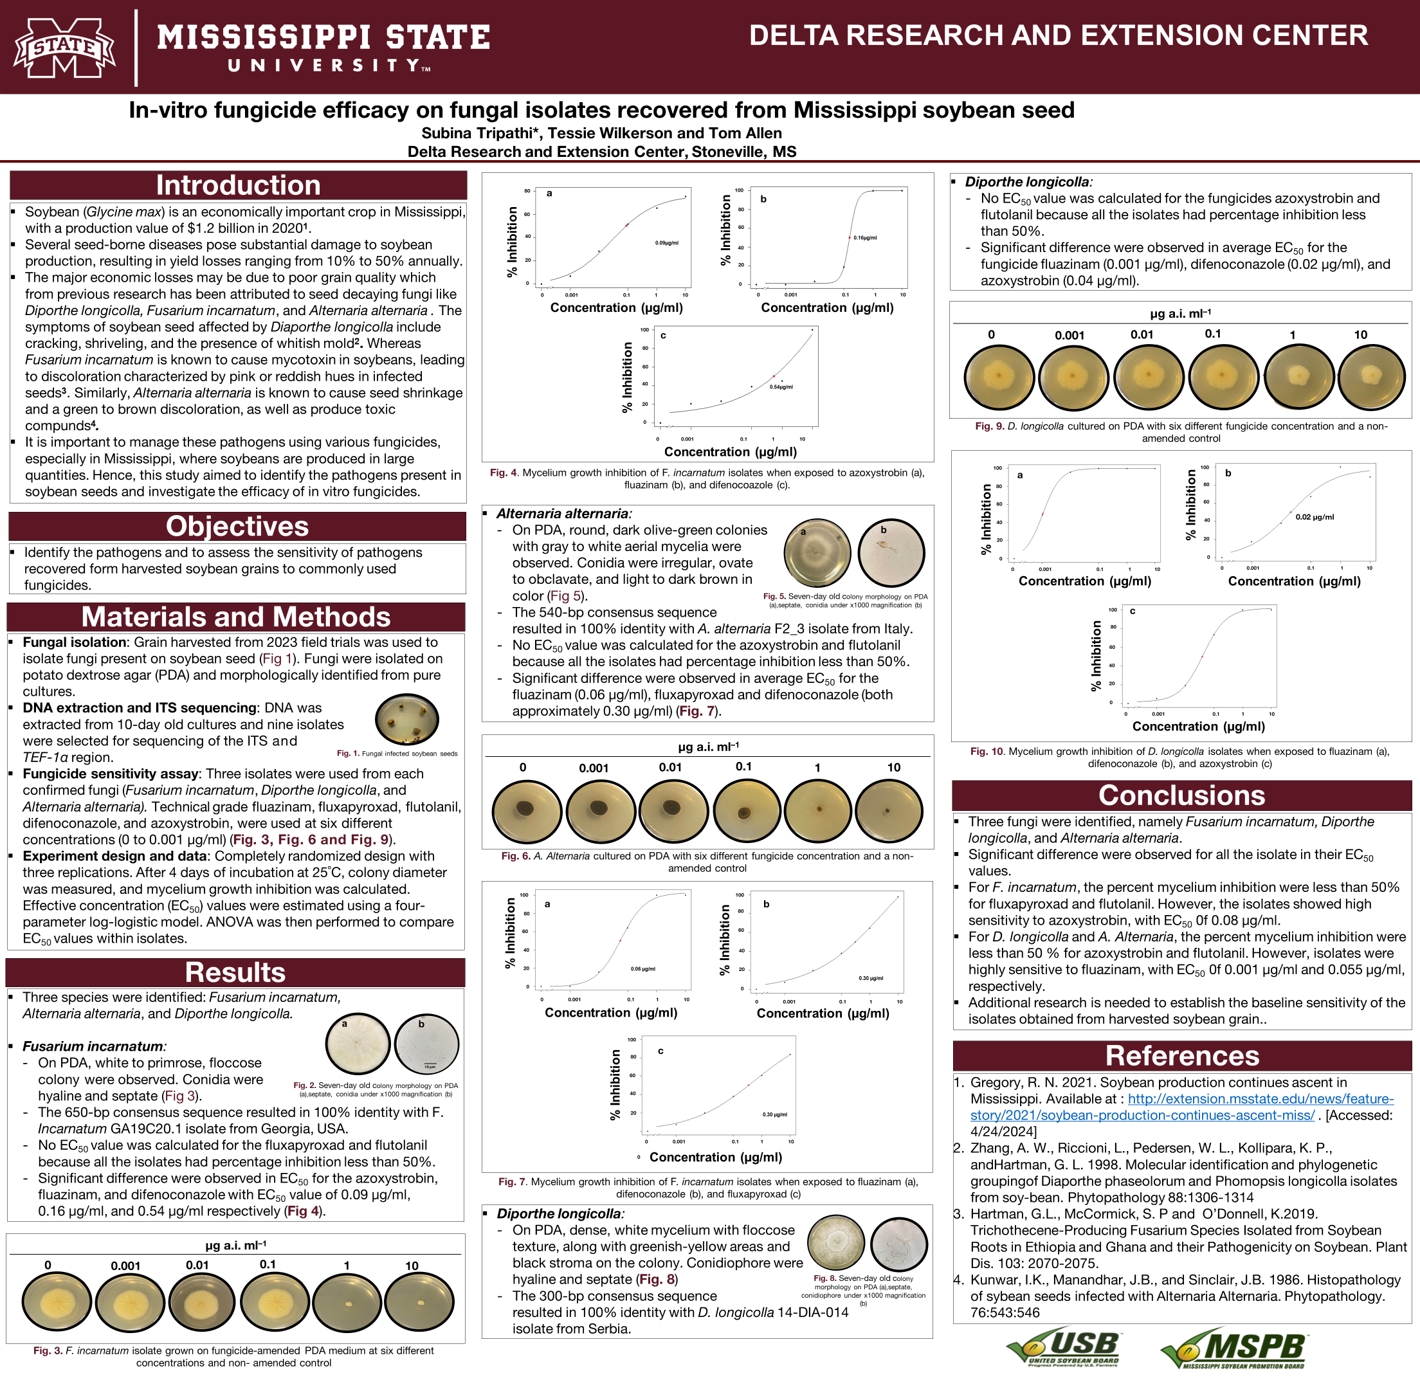

Table 1. 2022 - 2024 Copes seed quality trial summary harvest one - harvest four, Stoneville, Mississippi *x*

|  |  |  |  |  |  |  |  |  |
| --- | --- | --- | --- | --- | --- | --- | --- | --- |
|  | Harvest | | | | | | | |
|  | One | | Two | | Three | | Four | |
| Trt.* | Overall damage | Total wt. (kg) | Overall damage | Total wt. (kg) | Overall damage | Total wt. (kg) | Overall damage | Total wt. (kg) |
| Untreated | 1.3 | 3.7 | 0.5 | 3.0 | 1.0 | 3.0 | 1.1 | 2.7 |
| Miravis Top  13.7 Fl oz/a (R3) | 1.4 | 3.7 | 0.8 | 3.4 | 0.9 | 3.2 | 0.9 | 3.2 |
| Miravis Top  13.7 Fl oz/a (R3 + R6) | 1.2 | 3.9 | 0.9 | 3.4 | 1.0 | 3.2 | 0.9 | 3.9 |
| Miravis Top  13.7 Fl oz/a (R6) | 0.8 | 3.4 | 0.8 | 3.2 | 0.8 | 2.7 | 0.9 | 3.2 |
| Miravis Top  13.7 Fl oz/a (R3)  Dessicant (maturity) | 0.9 | 3.7 | 0.4 | 2.8 | 1.0 | 3.2 | 0.8 | 3.4 |
| Miravis Top  13.7 Fl oz/a (R6)  Dessicant (maturity) | 0.8 | 3.8 | 0.3 | 3.2 | 0.6 | 2.9 | 0.8 | 2.8 |
| Miravis Top  13.7 Fl oz/a (R3 + R6)  Dessicant (maturity) | 0.8 | 3.7 | 0.3 | 3.5 | 0.4 | 3.1 | 1.5 | 3.1 |
| MSE | 1.1 | 1.6 | 0.6 | 3.1 | 0.9 | 1.6 | 0.9 | 3.4 |
| CV | 101.5 | 33.8 | 140.6 | 54.9 | 118.2 | 42.1 | 100.6 | 58.2 |
| P | 0.7600 | 0.9799 | 0.4803 | 0.9840 | 0.8040 | 0.9783 | 0.7231 | 0.9230 |

*All treatments included NIS 0.25% v/v

*x*Test was planted at the Delta Research and Extension Center, Stoneville, MS.

Table 2. 2022 - 2024 Oops seed quality trial summary harvest one - harvest four, Stoneville, MS*x*

|  |  |  |  |  |  |  |  |  |
| --- | --- | --- | --- | --- | --- | --- | --- | --- |
|  | Harvest | | | | | | | |
|  | One | | Two | | Three | | Four | |
| Trt. | Overall disease | Total wt. (kg) | Overall disease | Total wt. (kg) | Overall disease | Total wt. (kg) | Overall disease | Total wt. (kg) |
| Dessicant 10.7 fl oz/a (R5) | 1.1 b-g | 3.2 a-f | 1.7 abc | 4.2 d-g | 2.6 | 6.2 b-h | 0.8 | 4.8 d-i |
| Dessicant 22 fl oz/a (R5) | 1.2 b-g | 2.1 def | 1.5 a-d | 3.3 fg | 2.8 | 4.1 hij | 0.8 | 3.7 g-j |
| Dessicant 32 fl oz/a (R5) | 1.7 a-d | 1.6 f | 1.9 ab | 2.9 g | 3.0 | 2.0 j | 1.5 | 1.9 j |
| Dessicant 10.7 fl oz/a (R6) | 1.0 c-g | 3.7 a-d | 1.1 cde | 5.6 a-e | 2.8 | 5.9 d-h | 1.3 | 6.1 b-g |
| Dessicant 22 fl oz/a (R6) | 1.2 b-g | 3.6 a-e | 0.7 e | 4.9 a-f | 2.3 | 3.9 hij | 0.5 | 5.2 b-i |
| Dessicant 32 fl oz/a (R6) | 0.8 b-g | 3.3 a-e | 1.1 cde | 4.8 b-g | 2.6 | 5.4 f-i | 0.5 | 4.5 f-j |
| Dessicant 10.7 fl oz/a (R6.5) | 1.8 ab | 4.4 ab | 1.4 a-e | 6.3 a-d | 3.0 | 8.4 a-d | 0.8 | 6.6 a-f |
| Dessicant 22 fl oz/a (R6.5) | 0.9 d-g | 4.5 ab | 1.4 a-e | 6.6 ab | 2.9 | 8.5 abc | 1.8 | 7.3 a-d |
| Dessicant 32 fl oz/a (R6.5) | 1.3 b-g | 3.9 abc | 1.3 a-e | 6.3 a-d | 2.9 | 8.9 a | 1.3 | 7.8 ab |
| Dessicant 10.7 fl oz/a (R7) | 2.1 a | 3.8 abc | 1.5 a-d | 7.0 a | 3.3 | 8.9 a | 1.0 | 6.0 b-g |
| Dessicant 22 fl oz/a (R7) | 1.8 abc | 4.7 a | 1.4 a-e | 6.5 abc | 3.3 | 7.7 a-f | 1.5 | 8.8 a |
| Dessicant 32 fl oz/a (R7) | 1.4 a-f | 4.3 ab | 1.5 a-d | 6.7 ab | 3.5 | 6.3 b-h | 1.0 | 7.6 ab |
| Miravis Top 13.7 fl oz/a + Dessicant 10.7 fl oz/a (R5) | 0.5 g | 2.6 c-f | 0.8 de | 4.4 c-g | 2.1 | 5.2 ghi | 0.5 | 4.7 e-i |
| Miravis Top 13.7 fl oz/a + Dessicant 22 fl oz/a (R5) | 0.9 d-g | 2.0 ef | 1.5 a-d | 3.4 efg | 2.4 | 4.1 hij | 1.0 | 3.4 hij |
| Miravis Top 13.7 fl oz/a + Dessicant 32 fl oz/a (R5) | 0.9 d-g | 1.6 f | 1.3 a-e | 3.2 fg | 2.9 | 3.4 ij | 1.0 | 2.8 ij |
| Miravis Top 13.7 fl oz/a + Dessicant 10.7 fl oz/a (R6) | 1.1 b-g | 3.8 abc | 0.7 e | 5.7 a-d | 2.5 | 8.2 a-d | 0.8 | 6.4 a-f |
| Miravis Top 13.7 fl oz/a + Dessicant 22 fl oz/a (R6) | 0.9 d-g | 2.9 b-f | 0.7 e | 5.0 a-g | 2.4 | 6.1 c-h | 0.8 | 5.5 b-h |
| Miravis Top 13.7 fl oz/a + Dessicant 32 fl oz/a (R6) | 0.5 g | 3.4 a-e | 1.3 a-e | 5.3 a-f | 2.1 | 5.5 e-i | 0.8 | 5.0 c-i |
| Miravis Top 13.7 fl oz/a + Dessicant 10.7 fl oz/a (R6.5) | 1.7 a-d | 4.2 abc | 1.7 abc | 6.4 a-d | 3.1 | 8.7 ab | 1.0 | 6.8 a-f |
| Miravis Top 13.7 fl oz/a + Dessicant 22 fl oz/a (R6.5) | 0.8 efg | 4.6 a | 1.5 a-d | 6.2 a-d | 2.5 | 7.5 a-g | 0.8 | 7.0 a-e |
| Miravis Top 13.7 fl oz/a + Dessicant 32 fl oz/a (R6.5) | 1.3 b-g | 4.1 abc | 1.8 abc | 6.0 a-d | 2.9 | 7.4 a-g | 1.3 | 7.0 a-e |
| Miravis Top 13.7 fl oz/a + Dessicant 10.7 fl oz/a (R7) | 1.8 ab | 4.4 ab | 1.8 abc | 6.5 abc | 3.0 | 8.6 abc | 1.5 | 7.5 abc |
| Miravis Top 13.7 fl oz/a + Dessicant 22 fl oz/a (R7) | 1.6 a-e | 4.7 a | 1.2 b-e | 6.1 a-d | 3.1 | 8.5 abc | 1.5 | 7.4 abc |
| Miravis Top 13.7 fl oz/a + Dessicant 32 fl oz/a (R7) | 1.8 abc | 4.3 ab | 2.0 a | 6.1 a-d | 3.0 | 8.0 a-e | 1.3 | 6.7 a-f |
| MSE | 0.9 | 4.0 | 1.0 | 7.1 | 2.9 | 3.2 | 0.4 | 3.3 |
| CV | 75.5 | 56.4 | 74.7 | 49.8 | 61.2 | 27.4 | 65.2 | 31.1 |
| P | <0.0001 | <0.0001 | 0.0330 | 0.0002 | 0.9967 | <0.0001 | 0.2971 | <0.0001 |

*All treatments included NIS 0.25% v/v

x Test was planted at the Delta Research and Extension Center, Stoneville, MS.

y Means followed by the same letter(s) within a column are not significantly different according to Fisher’s Protected LSD (P = 0.05)