**Assessing Micronutrients Application for Efficient Soybean Production in the Mississippi Delta (21-2023-2025)**

**Final Report**

PI: Ammar B. Bhandari, 662-686-5279, [Ammar.bhandari@usda.gov](mailto:Ammar.bhandari@usda.gov)

Co-PI: Tulsi P. Kharel, 662-686-5234, [Tulsi.kharel@usda.gov](mailto:Tulsi.kharel@usda.gov)

**1.0** **Background:**

The U.S. Department of Agriculture (USDA) reported that soybean (Glycine max L.) is Mississippi’s leading crop, with planted acreage rising significantly from 1,956,519 in 2012 to 2,300,000 in 2022. This dramatic expansion underscores the critical need for optimal nutrient management strategies to sustain productivity and enhance net farm profitability. Nutrient deficiencies during the growing season can induce crop stress, limit essential plant functions, and reduce yield and quality (e.g., protein and oil content), potentially wasting other inputs such as irrigation and macronutrients (Thapa et al., 2021). In response, renewed interest in micronutrients has emerged, driven by increased removal rates associated with high-yielding cultivars. As the adoption of these cultivars and overall soybean production in the Mississippi Delta grows, it becomes imperative to refine fertilizer management practices and validate current micronutrient fertilization protocols. Notably, previous studies have reported yield improvements; for instance, Orlowski et al. (2016) observed a 2.4% yield increase when applying a fertilizer containing Zn, Mn, Fe, and B in the Northern Corn Belt, suggesting that modern high-yielding cultivars may require augmented micronutrient supplementation, even though the specific impacts on yield and seed quality remain underexplored.

In the Mississippi Delta, soybeans are predominantly grown under irrigated conditions; however, the expansion of irrigated acreage has led to increased withdrawal from the Mississippi River Valley Alluvial Aquifer (MRVAA), whose recharge rates do not meet current extraction demands. This imbalance has resulted in aquifer declines of up to 0.4 meters annually in some locations (Massey, 2010), emphasizing the urgent need to reduce irrigation water use without sacrificing economic output, thereby mitigating further declines in the MRVAA (Yasarer et al., 2020; Quintana-Ashwell et al., 2022). Micronutrient applications have been shown to mitigate drought stress in soybeans (Heidarzade et al., 2016), and the current research project aims to evaluate multiple soybean cultivars alongside diversified water and micronutrient management strategies to develop sustainable, profitable production systems for the mid-southern USA. For producers operating without irrigation, targeted micronutrient applications such as foliar sprays of Fe and Mo, which have been proven to reduce drought-induced damage and enhance yields may also prove beneficial.

Furthermore, soybean producers assess crop value based on visual inspections and measured moisture content, with higher yields and elevated protein levels garnering premium prices. Increases as modest as 1% in protein content can boost soybean prices by $7.70 in Kansas and $9.07 in Missouri. Because nutrient management and irrigation practices directly affect soybean protein and oil composition, enhancing seed protein content through precise micronutrient management could significantly improve economic returns. Additionally, soybean meal, the primary by-product after oil extraction, is a crucial source of high-quality protein for livestock and poultry, meaning that improvements in seed protein content can further enhance farm profitability. Collectively, these insights underline the importance of integrated nutrient and water management strategies for cultivating high-quality soybeans under both irrigated and rainfed conditions.

**Justification:**

In recent years, increased soybean (Glycine max L.) cultivation driven by higher grain sale prices has promoted high-input management strategies, including micronutrient application (Orlowski et al., 2016; Gaspar et al., 2018). Micronutrients are fundamental to plant metabolism, and their deficiency impairs critical functions, leading to reduced yield and seed quality (Orlowski et al., 2016). Optimal nutrient management is, therefore, essential for maximizing yield, protecting soil health, enhancing farm profitability, and minimizing environmental impacts. Despite this, information on soybean micronutrient requirements and optimal application rates is limited (Enderson et al., 2015; Gaspar et al., 2018), particularly given that crop yield and nutrient needs vary with field conditions, soil mineralogy, genotype, and environment (Gaspar et al., 2018; Johnson & Fixen, 1990). Additionally, the combined effects of micronutrients and irrigation may influence the nutritional composition of soybean grains, such as protein and oil content (El-Haggan, 2014; Enderson et al., 2015; Zolfaghari et al., 2019), which is economically significant since even a 1% increase in protein content can raise processed soybean values by $7.70–$12.96 per acre (Cook, 2015). Micronutrient applications have also been shown to mitigate drought stress in soybeans (Heidarzade et al., 2016). Despite these potential benefits, specific micronutrient guidelines for soybeans in the Mississippi Delta are lacking. Therefore, it is imperative to rigorously test and validate the effects of micronutrient applications, with and without irrigation, to develop effective fertilization and water management strategies. This study aims to clarify the impacts of these factors on soybean yield and quality, providing valuable insights for the development of sustainable, high-performance production systems in the Mississippi Delta.

**Objective:**

The objective of the study was to investigate the impact of micronutrients application on soybean yield, and quality under fully irrigated and rainfed production system in the Mississippi Delta.

**2.0 Materials and Methods**

The study was conducted at a USDA-ARS research farm in Stoneville, MS, in a randomized split-plot design with four replications, where micronutrients application rate was whole plot, and fertilizer treatment was subplots. Within each replication, irrigation treatment was randomized, and 8 rows alley were placed in between irrigated and rainfed (no-irrigation) treatments The soil was Tunica clay with 55% clay, 28% silt, and 17% sand. Soybean variety 48XFO was planted on April 18, 2023, in 200 ft. plots with 8-rows and 38-inch row spacing. The micronutrient treatments were (i) zinc (Zn), (ii) iron (Fe), (iii) Zn + Fe, and (iv) control (C). Micronutrient treatment plots were randomized within each irrigation whole plot. The Zn and Fe was applied @5 and 2.5 lbs. ac-1 for low rate (LR) and 10 lbs. ac-1, and 5 lbs. ac-1 for high rate (HR), respectively. The source of micronutrients was 4% (individually formulated) Microcline™ liquid water-soluble Fe and Zn (<https://www.agroliquid.com/>). The first foliar application was 48 days after planting (DAP), and the second was 68 DAP. Recommended preemergence herbicides and postemergence insecticides programs were followed. Irrigation was applied on 6/8/2023, 6/27/2023, 7/27/2023, 8/4/2023 & 8/23/2023 and on 6/24/2024, 7/9/2024, 7/31/2024.The whole soybean plants were sampled at harvesting to record plants height, pod numbers, and number of nodes. The middle four rows were harvested with 8XP two row combine for yield and seed sub-samples were collected for quality analysis. The soybean seed moisture was adjusted to 13 % for yield.

2.1 Seed protein, oil, fatty acids, and amino acids analysis

Mature seeds were collected at physiological maturity and were ground using a Laboratory Mill 3600 (Perten, Springfield, IL). Seed protein, oil, fatty acids, amino acids, and sugars were determined in mature seed by a near-infrared reflectance spectrometer (NIRS™) DS3-F Analyzer using ISIscan™ Nova operating software (FOSS North America, Inc., Eden Prairie, MN, USA). The detector used was Silicon (850-1100 nm); Lead Sulfide (1100-2500 nm); the wavelength ranged from 850 to 2500 nm.

**2.2 Statistical analysis**

Response variables (soybean seed yields, seed protein, oil, fatty acids, sugars, etc.) were analyzed using the R. Experimental design was split plot with micronutrient rate (low vs. high) as main plot and micronutrient fertilizer treatments as sub-plot. Year, micronutrient rate, micronutrient treatments, and their interactions were designated as fixed effects, whereas blocks were treated as random effects for the model. Mean separations were determined using Fisher's protected least significant difference (LSD) at p≤0.05 when the analysis of variance (ANOVA) was significant at *p≤0.05,* respectively.

***3.0 Results and Discussion***

**3.1 Soybean grain yield:**

The analysis of variance (ANOVA) indicated that soybean yield was significantly influenced by both cropping year and micronutrient application rate (i.e., high versus low rates) across irrigated and rainfed production systems (Table 1). Under irrigated conditions, the results of 2023, although not statistically significant, demonstrated that low-rate applications of zinc (Zn at 5 lb ac⁻¹), iron (Fe at 2.5 lb ac⁻¹), and their combination (Zn + Fe) increased yield by 4.0%, 2.3%, and 1.4%, respectively (Figure 2A). Similarly, in 2024, the low rates of Zn, Fe, and Zn + Fe enhanced yield by 5%, 3%, and 1%, respectively (Figure 2A). In addition, high-rate applications under irrigated management in 2023 resulted in yield improvements of 2% (Zn) and 1% (Zn + Fe) relative to the control. However, no statistically significant differences were observed between irrigated and rainfed systems. In 2024, irrigated systems exhibited yield increases of 1%, 4%, and 2% after applying Fe, Zn, and Zn + Fe, respectively (Figure 2A). These findings suggest that judicious foliar application of micronutrients can enhance soybean productivity in high-yielding environments.

Under rainfed conditions, the response to micronutrient treatments was more variable. In 2023, low-rate applications of Zn (5 lb ac⁻¹) and the combined Zn + Fe (5 lb ac⁻¹ and 2.5 lb ac⁻¹, respectively) increased yield by 3.5% and 1.0%, respectively, compared to the control (Figure 2). In 2024, the same low application rates of Fe, Zn, and Zn + Fe resulted in 1%, 3%, and 2% yield gains, respectively. Notably, under high-rate treatments in 2023, only Zn produced a modest yield increase of 1.2%, whereas high rates of Fe and the Zn + Fe combination reduced yield by 2.8% and 1.4%, respectively. These adverse effects are likely attributable to foliar phytotoxicity (evidenced by leaf burn), which decelerated plant growth and development, thereby underscoring the necessity for optimizing micronutrient concentrations. In contrast, high-rate applications in 2024 under rainfed conditions led to yield increases of 6% (Zn) and 2% (Zn + Fe) compared with the control (Figure 2A).

These results underscore that while foliar micronutrient applications have the potential to enhance soybean yield, both the rate of application and the production environment (irrigated versus rainfed) critically influence the outcome. Future research should focus on fine-tuning application concentrations to maximize benefits while mitigating potential phytotoxic effects, particularly under rainfed conditions where stress factors may amplify adverse responses.

**3.2 Fiber, oil and protein content:**

Soybean seeds were analyzed for quality parameters, including fiber, oil, and protein. Under irrigated conditions, ANOVA results indicated that both the growing season and micronutrient application rates (high versus low) significantly influenced fiber content, and the application rate also affected oil content (Table 1). Under the rainfed production system, both the growing season and the micronutrient rate significantly impacted yield, fiber, and oil content (Table 1). However, protein content was unaffected under both production systems, and no significant overall micronutrient treatment effects were observed on fiber, oil, or protein content.

In the irrigated environment, fiber content was significantly higher in 2024 than in 2023. Moreover, the low micronutrient rate yielded a fiber content of 7.04% compared with 6.77% at the high rate (Figure 2B). In addition, oil content was statistically higher at the high micronutrient rate (21.86%) than at the low rate (21.58%). Under rainfed conditions, fiber content was again significantly higher in 2024 than in 2023, and overall, oil content was significantly higher at the high application rate (22.48%) compared with the low rate (22.27%) (Figure 2C).

**3.3 Plant growth parameters at harvesting and seed weight**

We recorded the average plant height, number of nodes per plant, and number of pods per plant at harvest, in addition to measuring the 1000-seed weight (Figures 3A–3D). Under the irrigated production system, the results showed that micronutrient treatments, year, and application rates did not significantly affect the average plant height or the number of nodes per plant (Figures 3A and 3B). Although micronutrient treatments and application rates did not impact the average number of pods per plant, a significant year effect was observed. In 2023, plants produced an average of 57 pods compared to 44 pods in 2024 (Figure 3C). The 1000-seed weight remained unaffected by year, micronutrient treatments, and application rates (Figure 3D).

Under the rainfed production system, neither micronutrient treatments, year, nor application rates influenced the average plant height or the number of nodes per plant (Figure 3B). Similarly, micronutrient treatments and application rates did not affect the average number of pods per plant, although the year effect persisted, with 2023 exhibiting a higher pod count than 2024 (Figure 3C). The results showed that 1000 seed weight was not affected by micronutrient treatments and year. However, the lower rate had a significantly greater seed weight (139 g) compared to the higher rate (133 g) (Figure 3D).

**3.4 Fatty acids composition:**

Soybean seeds were analyzed for their fatty acid composition, including palmitic, stearic, oleic, and linolenic acids. Under irrigated conditions, the ANOVA revealed that the growing season significantly influenced the levels of palmitic, stearic, and oleic acids during the 2023 cropping cycle (Table 2). Similarly, under the rainfed production system, the growing season significantly impacted the contents of palmitic, stearic, oleic, and linolenic acids (Table 2). Micronutrient treatments, on the other hand, did not significantly affect fatty acid composition in either production system. However, the micronutrient application rates demonstrated mixed effects on the fatty acid compositions in soybean seeds.

**3.5 Essential amino acids:**

The essential amino acid content in soybean seeds, such as arginine, isoleucine, leucine, lysine, methionine, cysteine, threonine, tryptophan, and valine, was analyzed for quality assessment.

Under the irrigated production system, leucine, methionine, cysteine, threonine, and tryptophan were significantly affected by year. The micronutrient treatments affected methionine and threonine, and micronutrient application rates affected isoleucine and valine (Table 3). The results revealed that the micronutrient treatment and application rates had two-way interaction and significantly affected the isoleucine, leucine, lysine methionine, threonine, tryptophan, and valine content in soybean seeds (Table 3). The methionine, threonine, and tryptophan showed significant three-way interaction due to micronutrient treatments, application rates, and year (Table 3). Under the rainfed production system, arginine, lysine, methionine, threonine, and tryptophan were significantly affected by year. The micronutrient treatments had no significant effect on any of the tested amino acid parameters (Table 4). Lysine showed a significant three-way interaction due to micronutrient treatments, application rates, and year (Table 3).

**4.0 Summary and Conclusions:**

Micronutrient application, particularly low rates of Zn and Fe, consistently increased soybean yield under both irrigated and rainfed production systems over the two years studied, with a synergistic effect observed between micronutrient application and irrigation. Although these practices enhanced yield, further research is needed to precisely quantify the impacts of varied micronutrient application rates and irrigation regimes on soybean yield. Regarding seed quality, the application of Fe and Zn produced mixed results; under irrigated conditions, a lower rate of Zn significantly increased oil content compared to the control. Interactions among micronutrient treatments, application rates, and year significantly modulated soybean amino acid composition. Treatments influenced methionine and threonine, while application rates affected isoleucine and valine, with several amino acids exhibiting significant two- and three-way interactions, particularly under rainfed conditions. These variable responses suggest that further studies incorporating multiple soybean cultivars, micronutrient application rates, and different soil types are needed to fully understand the effects on soybean seed quality. The research findings offer valuable insights for Mississippi soybean producers to develop new strategies for cultivating high-quality soybeans under both irrigated and rainfed conditions with micronutrient applications.

**Presentations and publications resulting from this project**

*Presentations:*

Bhandari, A.B., Kharel, T. P and Bellaloui, N. 2024. Soybean Yield Response to Micronutrients Application in the Mississippi Delta. Mississippi Academy of Sciences, Feb 19- Mar 1, 2024. Hattiesburg, MS.

*Manuscript under review:*

Debnath, R., George, J., Bhandari, A.B., Kariyat, R., Reddy, G.VP., Glover, J., Kharel, T.P., and Reddy, K. N. Impact of irrigation and micronutrient treatments on insect herbivore population dynamics in soybean. Frontiers in Agronomy. Submitted February 5, 2025.

**References**

Cook, W. J. (2015). Three reasons why high protein soybeans pay. BigYield.US. <https://www.bigyield.us/three-reasons-why-high-protein-soybeans-pay/> (accessed on March 20, 2024).

Enderson, J. T., Mallarino, A. P., & Haq, M. U. (2015). Soybean yield response to foliar-applied micronutrients and relationships among soil and tissue tests. *J. Agron,* 107(6), 2143-2161. <https://doi.org/10.2134/agronj14.0536>.

Gaspar, A. P., Laboski, C. A. M., Naeve, S. L., & Conley, S. P. (2018). Secondary and micronutrient uptake, partitioning, and removal across a wide range of soybean seed yield levels. *Agronomy Journal,* 110(4), 1328–1338. <https://doi.org/10.2134/agronj2017.12.0699>

El-Haggan, E. A. L. M. A. (2014). Effect of micronutrients foliar application on yield and quality traits of soybean cultivars. *International Journal of Agriculture and Crop Sciences,* 7(11), 908–914.

Heidarzade, A., M. Esmaeili, M. Bahmanyar, and Abbasi, R. (2016). Response of soybean (Glycine max) to molybdenum and iron spray under well-watered and water deficit conditions. J. Exp. Biol. Agric. Sci. 4: 38-46. doi: 10.18006/2015.4(1).37.46.

Johnson, G.V., & Fixen, P.E. (1990). Testing soils for sulfur, boron, molybdenum, and chlorine. In: R.L. Westerman, editor, Soil testing and plant analysis. 3rd ed. SSSA, Madison, WI. p. 265–273.

Orlowski, J.M., Haverkamp, B.J., Laurenz, R.G., Marburger, D.A., Wilson, E.W., Casteel, S.N., Conley, S. L., Naeve, S. L., Nafziger, E.D., Roozeboom, K. L., Ross, W.L., Thelen, K.D., & Lee, C.D. (2016). High-Input management systems effect on soybean seed yield, yield components, and economic Break-Even probabilities. *Crop Sci.,* 56 (4), 1988-2004.

Quintana‐Ashwell, N., Anapalli, S.S., Pinnamaneni, S.R., Kaur, G., Reddy, K.N., Fisher, D. 2022. Profitability of twin‐row planting and skip‐row irrigation in a humid climate. Agron. J. 114 (2), pp. 1209-1219, 10.1002/agj2.20847

Thapa, S., Bhandari, A.; Ghimire, R., Xue, Q., Kidwaro, F., Ghatrehsamani, S., Maharjan, B., Goodwin, M. (2021). Managing Micronutrients for Improving Soil Fertility, Health, and Soybean Yield. *Sustainability,* 13, 11766. <https://doi.org/10.3390/su132111766>

Yasarer, L. M. W., Taylor, J. M., Rigby, J. R., Locke, M. A. 2020. Trends in land use, irrigation, and streamflow alteration in the Mississippi River Alluvial Plain. Front. Environ. Sci. 8, 66. <https://doi.org/10.3389/fenvs.2020.00066>

Zolfaghari, M. G., Pasari, B., Shams, K., Rokhzadi, A., & Mohammadi, K. (2019). The effect of micronutrient foliar application on yield, seed quality and some biochemical traits of soybean cultivars under drought stress. Journal of Plant Nutrition, 42:20, 2715-2730, DOI: 10.1080/01904167.2019.1655034

|  |  |  |  |  |  |  |  |  |
| --- | --- | --- | --- | --- | --- | --- | --- | --- |
| **Table 1. Analysis of Source of variation (ANOVA) for treatments mean comparison of yield (Bu ac-1), fiber (%), oil (%) and protein (%) content in irrigated and rainfed production system, 2023-2024** | | | | | | | | |
| Source of variation | Irrigated production system | | | | Rainfed production system | | | |
| Yield | Fiber | Oil | Protein | Yield | Fiber | Oil | Protein |
| Year (Y) | * | * | N.S. | N.S. | * | * | ** | N.S. |
| Micronutrients (M) | N. S. | N.S. | N.S. | N.S. | N.S. | N.S. | N.S. | N.S. |
| Micronutrients rate (MR) | * | * | * | N.S. | * | ** | * | N.S. |
| Y*M | N.S. | N.S. | * | N.S. | N.S. | N.S. | N.S. | N.S. |
| Y*MR | N.S. | * | N.S. | N.S. | N.S. | N.S. | N.S. | N.S. |
| M*MR | NS | N.S. | * | N.S. | N.S. | N.S. | ** | N.S. |
| M*MR*Y | NS | N.S. | N.S. | N.S. | N.S. | N.S. | N.S. | N.S. |
| *, ** Significant at the 0.05 and 0.10 probability level; N.S. nonsignificant at the 0.05 probability level. | | | | | | | | |

|  |  |  |  |  |  |  |  |  |
| --- | --- | --- | --- | --- | --- | --- | --- | --- |
| **Table 2. Analysis of Source of variation (ANOVA) for treatments mean comparison of fatty acids composition (%) in irrigated and rainfed production system, 2023-2024** | | | | | | | | |
| Source of variation | Irrigated production system | | | | Rainfed production system | | | |
| Palmitic acid | Stearic acid | Oleic acid | Linoleic acid | Palmitic acid | Stearic acid | Oleic acid | Linoleic acid |
| Year (Y) | * | * | * | N.S. | * | * | * | * |
| Micronutrients (M) | N. S. | N.S. | N.S. | N.S. | N. S. | N.S. | N.S. | N.S. |
| Micronutrients rate (MR) | N. S. | N.S. | N.S. | * | ** | N.S. | N.S. | * |
| Y*M | N.S. | N.S. | N.S. | N.S. | N.S. | N.S. | N.S. | N.S. |
| Y*MR | * | N.S. | N.S. | N.S. | * | ** | N.S. | N.S. |
| M*MR | N.S. | * | N.S. | N.S. | NS | N.S. | N.S. | N.S. |
| M*MR*Y | N.S. | N.S. | N.S. | N.S. | NS | N.S. | N.S. | N.S. |
| *, ** Significant at the 0.05 and 0.10 probability level; N.S. nonsignificant at the 0.05 probability level. | | | | | | | | |

|  |  |  |  |  |  |  |  |  |  |
| --- | --- | --- | --- | --- | --- | --- | --- | --- | --- |
| **Table 3. Analysis of Source of variation (ANOVA) for treatments mean comparison of essential amino acids (%) in an irrigated production system, 2023-2024** | | | | | | | | | |
| Source of variation | Arginine | Isoleucine | Leucine | Lysine | Methionine | Cysteine | Threonine | Tryptophan | Valine |
| Year (Y) | N.S. | N.S. | ** | N.S. | * | ** | * | * | N.S. |
| Micronutrients (M) | N. S. | N. S. | N.S. | N.S. | * | N.S. | * | N.S. | N.S. |
| Micronutrients rate (MR) | N. S. | ** | N.S. | N.S. | N.S. | N.S. | N.S. | N.S. | * |
| Y*M | N.S. | N.S. | N.S. | N.S. | N.S. | N.S. | N.S. | N.S. | N.S. |
| Y*MR | N.S. | N.S. | ** | N.S. | N.S. | ** | N.S. | N.S. | ** |
| M*MR | N.S. | * | ** | ** | ** | N.S. | * | * | ** |
| M*MR*Y | N.S. | N.S. | N.S. | N.S. | ** | N.S. | ** | * | N.S. |
| *, ** Significant at the 0.05 and 0.10 probability level; N.S. nonsignificant at the 0.05 probability level. | | | | | | | | |  |

|  |  |  |  |  |  |  |  |  |  |
| --- | --- | --- | --- | --- | --- | --- | --- | --- | --- |
| **Table 4. Analysis of Source of variation (ANOVA) for treatments mean comparison of essential amino acids (%) in rainfed production system, 2023-2024** | | | | | | | | | |
| Source of variation | Arginine | Isoleucine | Leucine | Lysine | Methionine | Cysteine | Threonine | Tryptophan | Valine |
| Year (Y) | * | N.S. | N.S. | * | * | N.S. | * | * | N.S. |
| Micronutrients (M) | N. S. | N. S. | N.S. | N.S. | N.S. | N.S. | N.S. | N.S. | N.S. |
| Micronutrients rate (MR) | N. S. | N.S. | N.S. | N.S. | N.S. | N.S. | N.S. | N.S. | N.S. |
| Y*M | N.S. | N.S. | N.S. | N.S. | N.S. | N.S. | N.S. | N.S. | N.S. |
| Y*MR | N.S. | N.S. | N.S. | N.S. | N.S. | N.S. | N.S. | N.S. | N.S. |
| M*MR | N.S. | N.S. | N.S. | N.S. | N.S. | N.S. | N.S. | N.S. | N.S. |
| M*MR*Y | N.S. | N.S. | N.S. | * | N.S. | N.S. | N.S. | N.S. | N.S. |
| *, ** Significant at the 0.05 and 0.10 probability level; N.S. nonsignificant at the 0.05 probability level. | | | | | | | | |  |

**FIGURES:**

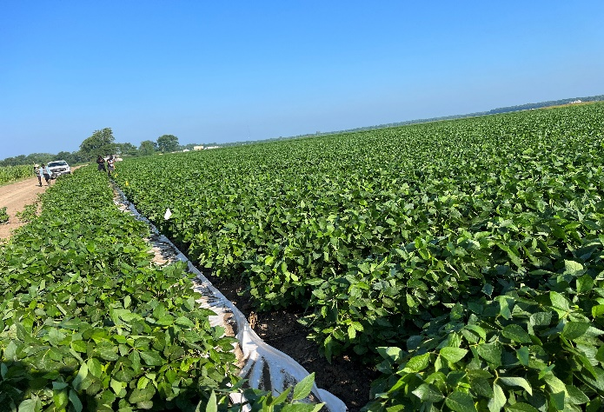

**(b)**

**(d)**

**(a)**

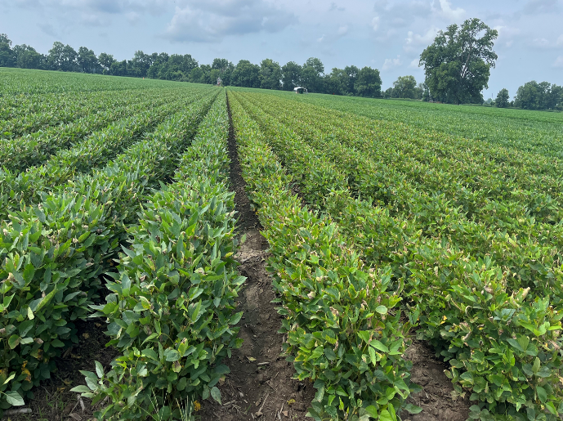

**(c)**

Figure 1. Soybean field. (a) Soybean growing under irrigated environment; (b) Soybean growing under rainfed (no-irrigation) environment (c) Soybean field next day after 2nd dose of zinc (left) and iron (right) fertilizer application (d) Soybean field after 2 weeks of zinc and iron treatments in 2023.

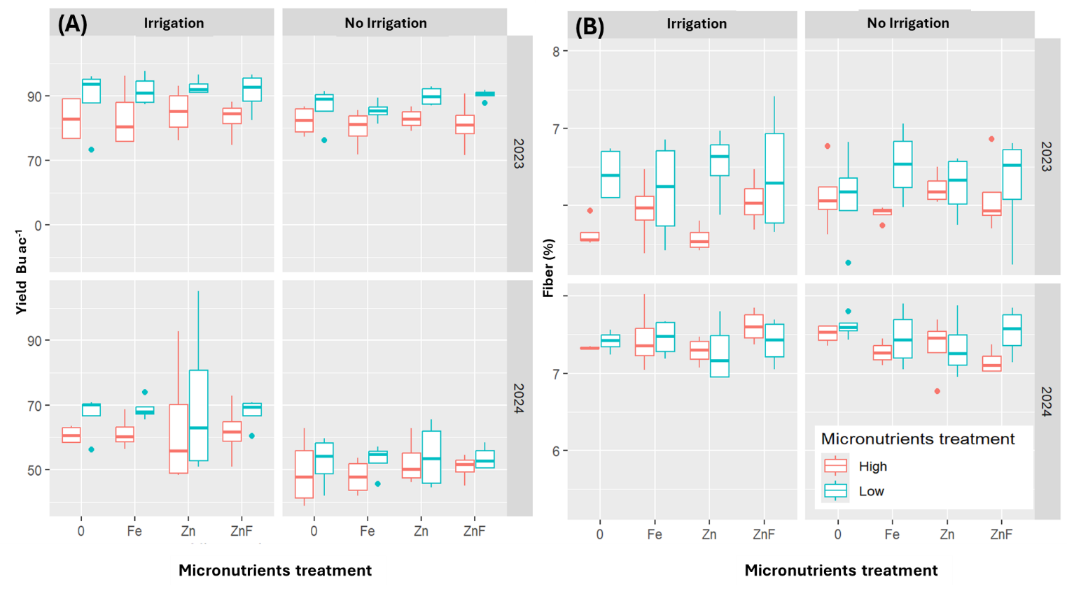

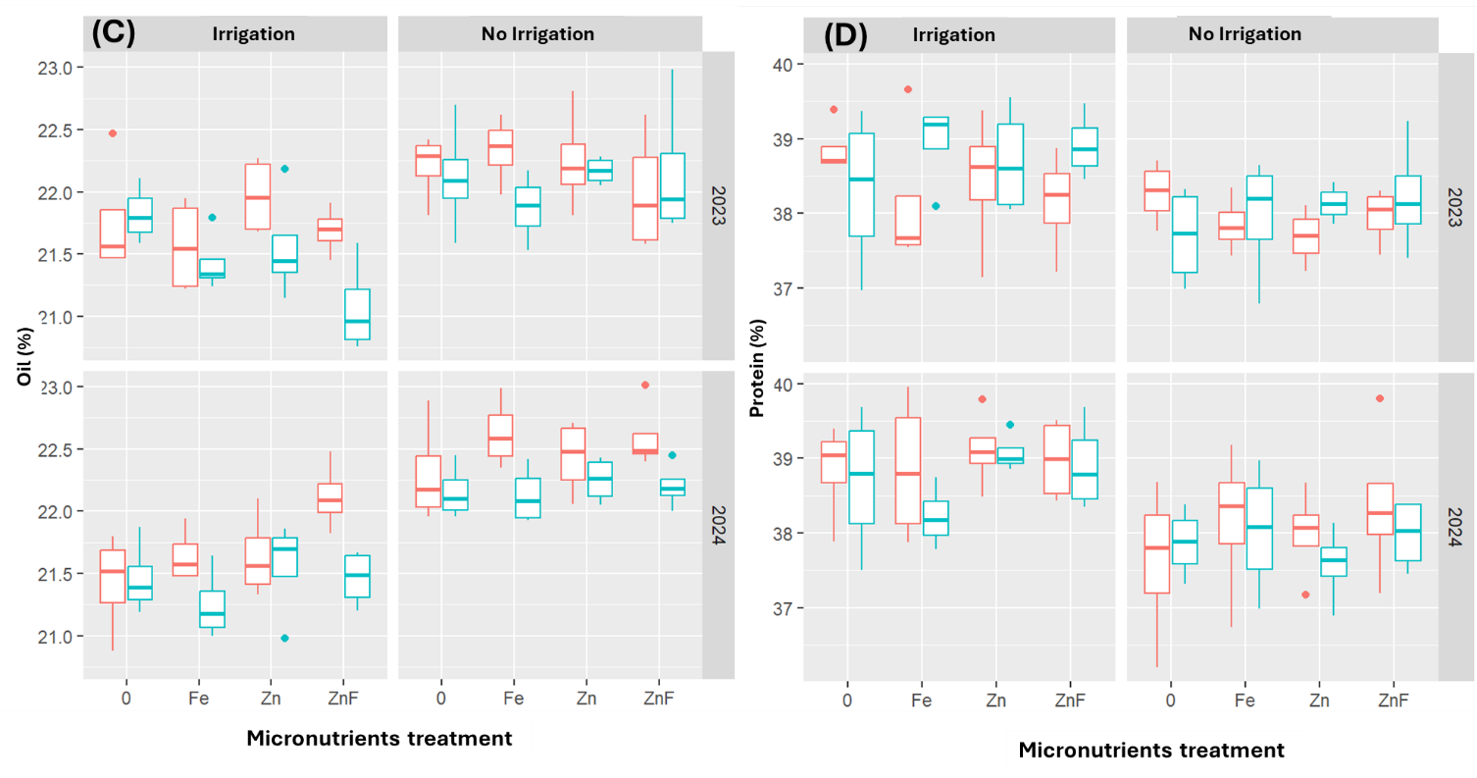

Figure 2. Soybean response to micronutrients application and irrigation. A) soybean yield, B) Soybean seed fiber content, C) Soybean seeds oil content, D) Soybean seed protein content.

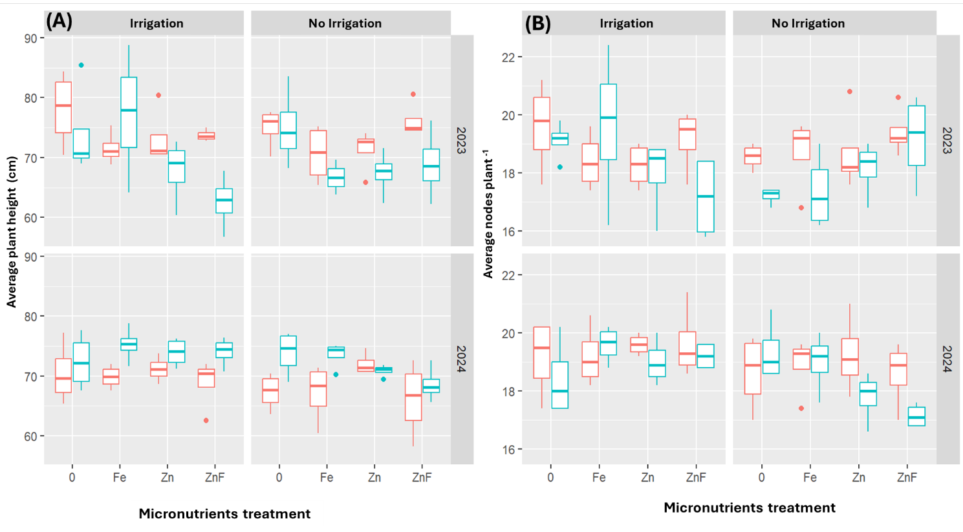

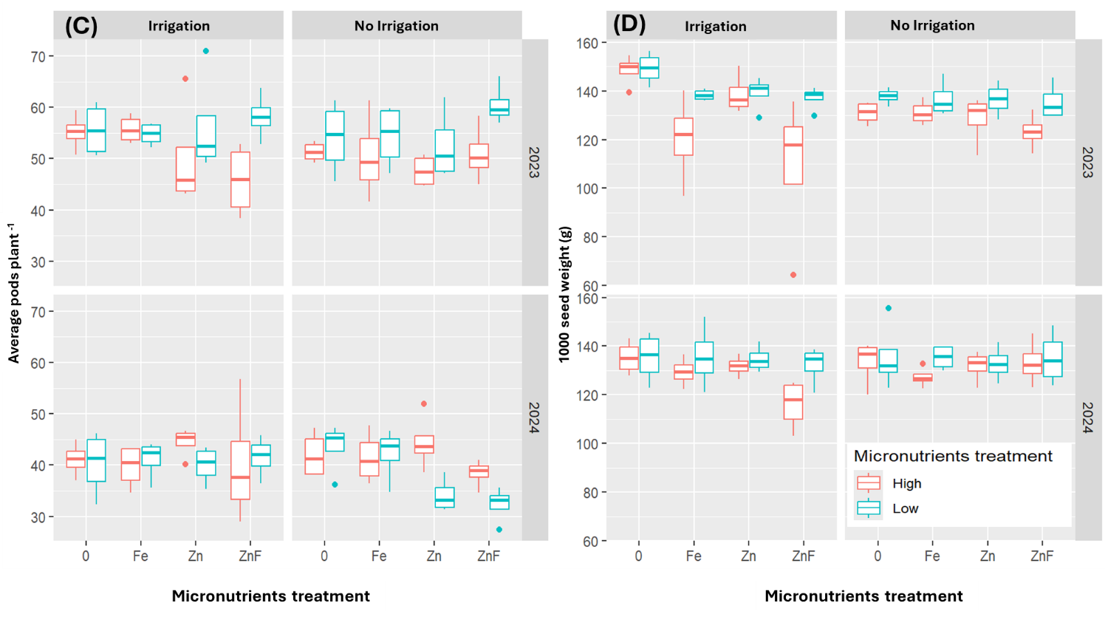

Figure 3. Soybean growth parameters response to micronutrients application and irrigation. A) Average soybean plant height at harvesting B) Average nods per plant at harvesting, C) Average pods per plant at harvesting, D) 1000 seed weight in gram.