**Effect of seed priming with acetic acid on growth and yield of soybean grown on non-irrigated sites (MSPB Project No.: 30-2024)**

**ANNUAL REPORT**

**Name of PI:** Jiaxu Li   
**Email address:** JL305@bch.msstate.edu

**Background and Objectives**

Drought is the major environmental factor limiting soybean productivity. Drought occurring at the flowering stage can result in decreased fertility and reduce the yield potential of soybeans. Over 50 percent of Mississippi soybeans are grown on dryland or non-irrigated sites. These soybean plants are more susceptible to yield loss fromdrought stress. The Intergovernmental Panel on Climate Change predicts that drought will increase in intensity and frequency in the United States, especially in Southern states. Therefore, there is a great need to develop production systems to maintain consistent yields of soybeans grown on dryland or non-irrigated sites across years.

Acetic acid application has recently been reported to increase water use efficiency and improve drought tolerance in several crops. These resent reports of acetic acid-enhanced drought tolerance across a range of plant species encourage consideration of this low-cost organic acid as a biostimulant. Further studies suggest that acetic acid functions as an epigenetic priming factor for gene activation. Thus, acetic acid application can establish the ready to go status for gene activation on the genome-wide scale prior to the stress condition, and effectively enhance the transcription of drought-responsive genes once the stress condition is encountered. Seed priming involves prior exposure to chemical agents which brings a cellular state that hinders the harmful effects of abiotic stress, and plants raised after priming are more tolerant of abiotic stress. Our preliminary studies in the greenhouse indicate that seed priming with acetic acid could improve growth and drought tolerance in soybean plants.

In this project, we proposed to test the effects of seed priming with acetic acid on the growth and yield of soybeans grown on non-irrigated sites. The specific objectives of the project are listed below:

1) to evaluate the effects of seed priming with acetic acid on the vegetative growth of soybeans grown on non-irrigated sites;

2) to evaluate the effects of seed priming with acetic acid on the seed yield of soybeans grown on non-irrigated sites.

**Report of Progress/Activity**

Objective 1: **Effects of seed priming with acetic acid on vegetative growth of soybeans grown on non-irrigated sites**

Two soybean varieties (Delta Grow 48XF33STS and Progeny 4806XFS) wereused in this study. Seeds of the two varieties were primed with acetic acid solutions (5 mM and 10 mM) for 6 hours and then dried to their original moisture content at room temperature for 72 hours. Primed soybean seeds with acetic acid and controls were planted in the field on the W. B. Andrews Agricultural Systems Research Farm of the Mississippi Agricultural and Forestry Experiment Station on May 15, 2024.

To evaluate the effects of seed priming with acetic acid on vegetative growth of soybeans grown on non-irrigated sites, growth parameters such as plant height and shoot fresh weight were measured. The measurements were conducted on soybean plants grown on non-irrigated sites (60 days after sowing). Six individual plants from each plot were randomly selected for the measurements. Plant heights were measured using a ruler to quantify the distance from the soil surface to the tip of the main stem.Fresh weights of the aboveground parts of soybean plants were recorded by a portable digital balance. The measuring data show that plant height and shoot fresh weight were higher in plants grown from seeds primed with acetic acid solutions (5 mM and 10 mM) than those grown from unprimed seeds (Figures 1 and 2). These results suggest that seed priming with acetic acid enhances vegetative growth of soybeans grown on non-irrigated sites. These data/results are preliminary, and we are going to carry out field study to determine the effect of seed priming with acetic acid on vegetative growthof soybean grown non-irrigated sites in the 2025 planting and growing season.

Objective 2: **Effects of seed priming with acetic acid on the yield of soybeans grown on non-irrigated sites**

The two soybean varieties (Delta Grow 48XF33STS and Progeny 4806XFS) grown on non-irrigated sites (MAFES W. B. Andrews Agricultural Systems Research Farm) were harvested on October 4, 2024. We have completed analysis of the effects of seed priming with acetic acid on the yield of soybeans grown on non-irrigated sites in 2024. The grain yields were 50.9 and 46.2 bushels/acre for Progeny 4806XFS soybeans grown from seeds primed with 5 mM and 10 mM acetic acid solutions respectively as compared to 41.3 bushels/acre from those grown from unprimed seeds (Figure 3). The grain yields were 63.1 and 61.9 bushels/acre for Delta Grow 48XF33STS soybeans grown from seeds primed with 5 mM and 10 mM acetic acid solutions respectively as compared to 50.4 bushels/acre from those grown from unprimed seeds (Figure 3). These results indicate that for both soybean varieties priming soybean seeds with acetic acid significantly increased grain yield compared with non-primed seeds grown on non-irrigated site in the 2024 growing season. These data/results are preliminary, and we will repeat the field study and assess the effects of seed priming with acetic acid on the grain yield of soybeans grown on non-irrigated sites in the 2025 growing season.

We analyzed 100-seed weight of two soybean varieties (Delta Grow 48XF33STS and Progeny 4806XFS) grown on non-irrigated sites in 2024. Mean values for 100-seed weight were 17.2, 16.9, and 16.7 grams per 100 seeds for Progeny 4806XFS soybeans grown from unprimed seeds, and seeds primed with 5 mM and 10 mM acetic acid solutions, respectively. For Delta Grow 48XF33STS, mean values for 100-seed weight were 17.4, 16.9, and 16.8 grams per 100 seeds for soybeans grown from unprimed seeds, and seeds primed with 5 mM and 10 mM acetic acid solutions, respectively. These results show that weight of 100 seeds of soybean (seed size) was not significantly different for both varieties from acetic acid-primed seeds compared with non-primed seeds grown on non-irrigated site in the 2024 growing season. These results suggest that seed size as indicated by weight of 100 seeds may not be a key factor contributing to increased grain yield for both soybean varieties grown from acetic acid-primed seeds in the 2024 growing season. Seed number per plant or pods per plant may be an important factor contributing to increased grain yield for both soybean varieties grown from acetic acid-primed seeds in 2024. These data/results are preliminary, we will repeat the field study and assess the effects of seed priming with acetic acid on the grain yield and yield component factor of soybeans grown on non-irrigated sites in the 2025 growing season.

**Impacts and Benefits to Mississippi Soybean Producers**

Water deficit stress constrains plant growth and reduces crop yield. Drought can hit soybean plants at any time during summer in southern states such as Mississippi. Thus, there are needs to develop effective strategies to cope with drought for soybean production. We have found that seed priming with acetic acid can significantly improve vegetative growth and grain yield of soybeans under non-irrigated (drought) conditions. The anticipated outcome of this project is the development of seed priming with acetic acid as an operative technique to improve soybean growth and yield under water limiting conditions. This research is highly likely to establish an effective drought coping strategy for the Mississippi soybean industry, which should benefit all the Mississippi soybean farmers who grow their soybeans on non-irrigated sites and dryland.

**End Products–Completed or Forthcoming**

Publications:

Sah SK, Popescu GV, Reddy KR, Klink VP, and **Li J**. (2025) The *Glycine max* abscisic acid-activated protein kinase-like kinase 1 (*GmAALK1*) modulates drought stress response. Journal of Plant Growth Regulation 44:1642-1663.

It is expected that we will have at least one more peer-reviewed scientific publication.

Presentations:

Susmita Ghimire and **Jiaxu Li**. "Effect of seed priming with acetic acid on growth and yield of soybean grown on nonirrigated sites" A poster for the Mississippi Academy of Sciences 84th Annual Meeting (March 20-21, 2025, Biloxi, MS).

**Graphics/Tables**

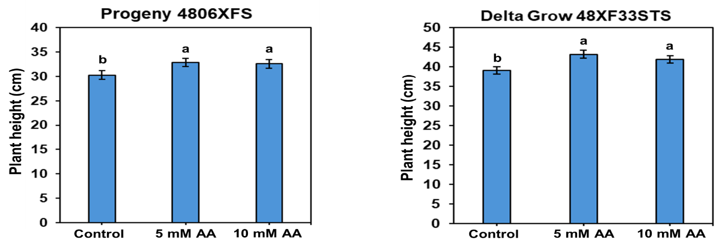

Figure 1. **Effects of seed priming with acetic acid (AA) on plant height of two soybean varieties grown on nonirrigated site.**

Bars indicate the standard deviation of the means. Different letters between them indicate a significant difference by the Tukey test at 5% of probability.

**Figure 2. Effects of seed priming with acetic acid (AA) on shoot fresh weight of two soybean varieties grown on nonirrigated site.** Bars indicate the standard deviation of the means. Different letters between them indicate a significant difference by the Tukey test at 5% of probability.

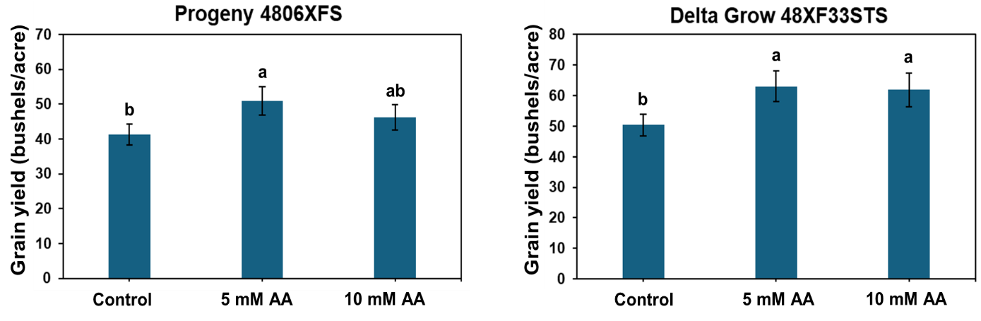

Figure 3. **Effects of seed priming with acetic acid (AA) on grain yield of two soybean varieties grown on nonirrigated site.**

Bars indicate the standard deviation of the means. Different letters between them indicate a significant difference by the Tukey test at 5% of probability.