**Development of molecular diagnostic method for the diamide resistance in Soybean looper, 32-2024**

**Final Reports**

PI: Seung-Joon Ahn, [seungjoon.ahn@msstate.edu](mailto:seungjoon.ahn@msstate.edu), 662-325-7516

Co-PI: Fred R. Musser, [fm61@msstate.edu](mailto:fm61@msstate.edu), 662-325-2974

PhD student: Sena Isbilir, [si240@msstate.edu](mailto:si240@msstate.edu), 662-325-7516 *(Graduated in December 2024)*

**Background and Objectives**

The soybean looper (*Chrysodeixis includens*) is a major defoliating pest of soybean, migrating north from southern regions through Mississippi in August and September. Since the introduction of diamide insecticides like chlorantraniliprole, soybean looper populations have been effectively managed with no significant resistance issues. Diamides target ryanodine receptors (RyR), intracellular calcium channels essential for muscle and nerve function. However, given the soybean looper’s history of resistance to pyrethroids, carbamates, and organophosphates, resistance to diamides is likely to emerge. Growers must be prepared for future management challenges should diamides lose efficacy. Diamide resistance has already been reported in several lepidopteran pests, including the diamondback moth, tomato leaf miner, rice stem borer, and beet armyworm in various regions. Although no confirmed cases of diamide resistance in soybean looper have been reported, reduced efficacy has been observed in the southeastern United States, particularly in populations suspected to have migrated from Puerto Rico. Regular resistance monitoring in Mississippi is crucial to help farmers select the most effective insecticides. For the past two years, we have monitored soybean looper populations for diamide resistance. While bioassays provide direct field-relevant data, they require significant time and effort. Field populations must be collected alive, reared for multiple generations under controlled conditions, and then tested. In contrast, molecular markers could provide a faster and more efficient resistance detection method. Unlike bioassays, molecular diagnostics do not require live insects—resistance can be detected from any developmental stage or even from body parts like legs. This makes molecular diagnostics a practical, proactive tool for resistance monitoring, allowing farmers to make informed insecticide choices before resistance becomes widespread.

Over the past four years, this project has focused on the following key objectives:

* **Objective 1:** Establish and bioassay a diamide-resistant soybean looper strain.
* **Objective 2:** Analyze ryanodine receptor (RyR) for target-site resistance.
* **Objective 3**: Investigate transcriptome profiles for metabolic resistance.
* **Objective 4:** Develop molecular markers for diamide resistance.

**Report of Progress/Activity**

This study aimed to establish a diamide-resistant strain of soybean looper (*Chrysodeixis includens,* Fig. 1) from Puerto Rico (PR) and investigate resistance mechanisms. PR field populations were established in laboratory and assayed with chlorantraniliprole, resulting in a 10-fold resistance ratio (RR) compared to a susceptible lab strain. Bioassays on PR populations from 2021 (PR21) and 2024 (PR24) revealed moderate (10×) and minimal (1.5×) resistance, respectively, suggesting genetic variation in resistance levels. Target-site resistance was explored by screening the ryanodine receptor (RyR) gene, focusing on six potential mutation sites, with Y4667C/D being the most prevalent in PR21 and PR24. However, field populations from Tennessee, Louisiana, and Mississippi showed low mutation frequencies, and no direct correlation between Y4667C and resistance was found, indicating other resistance mechanisms. Metabolic resistance was investigated through transcriptomic analysis, identifying upregulated cytochrome P450s (CYPs), glutathione S-transferases (GSTs), and other detoxification genes. Among these, CincCYP11051 showed significant upregulation in the PR strain following chlorantraniliprole exposure, suggesting a strong role in metabolic resistance. To develop a rapid and accurate molecular diagnostic marker, the strain-specific Y4667C mutation site of RyR was tested using a PCR-RFLP assay, although its direct association with diamide resistance remains inconclusive. Nevertheless, it serves as a useful molecular marker for distinguishing PR-derived populations from inland populations. This research advances our understanding of soybean looper adaptation and provides molecular tools for resistance monitoring and management. Future studies will validate detoxification gene function, refine diagnostic markers, and assess the stability of resistance, contributing to more sustainable pest control strategies. The following sections provide details on individual research objectives.

The following sections provide details on individual research objectives:

**Objective 1:** Establish and bioassay a diamide-resistant soybean looper strain.

Developing a stable and reliable diamide-resistant soybean looper colony is essential for studying resistance mechanisms and evaluating management strategies. The initial step involved collecting field populations from multiple locations including Puerto Rico. These populations were reared under controlled laboratory conditions and subjected to chlorantraniliprole exposure to test for resistance.

To measure the degree of resistance to chlorantraniliprole, we conducted bioassays using third-instar larvae. The lethal concentration required to kill 50% of the population (LC50) was determined for each generation. A susceptible lab strain was maintained for comparative analysis. By the second year, we had established a resistant colony with an RR of approximately 10-fold compared to the susceptible strain (Table 1). Additional tests revealed moderate cross-resistance to other diamides, including cyantraniliprole and flubendiamide. Field strains from Louisiana, Mississippi, and Puerto Rico were incorporated into resistance monitoring to assess geographic variations.

In the third year, efforts focused on stabilizing resistance levels while maintaining colony health and genetic diversity. Additional studies examined fitness costs associated with resistance, including developmental time, fecundity, and survival in the absence of insecticide pressure. Interestingly, resistant strains exhibited slightly slower development and reduced reproductive output, suggesting a trade-off that could influence resistance dynamics in field populations. This resistant colony now serves as a critical resource for molecular and biochemical studies on resistance mechanisms.

Bioassays were conducted on F3 and F5 progenies of the PR21 population and the F2 progeny of PR24mix to assess chlorantraniliprole resistance. Third-instar larvae (20–40 mg) were fed an artificial diet treated with six concentrations of chlorantraniliprole in rearing cups. A minimum of 120 larvae per strain per generation were tested for PR21, while PR24mix had at least 150 larvae per replicate. PR21 exhibited moderate resistance (10×) to chlorantraniliprole, maintaining consistency across F3 and F5 generations, indicating a potential genetic basis. In contrast, PR24 displayed minimal resistance (1.5×), suggesting a lack of significant adaptation to the insecticide.

These findings highlight the persistence of chlorantraniliprole resistance in PR21, emphasizing the need for further investigation into its genetic mechanisms. Understanding the molecular mechanisms underlying diamide resistance in soybean looper is crucial for effective pest management. Our study further explores target-site mutations (Objective 2) and metabolic detoxification (Objective 3) to determine key contributors to resistance.

**Objective 2:** Analyze ryanodine receptor (RyR) for target-site resistance.

First of all, the full‐length cDNA of the RyR gene was identified from soybean looper, which includes a 15,375 bp-long open reading frame (ORF) encoding a single RyR subunit of 5,124 aa-long protein. Genomic analysis revealed that the RyR gene consists of 113 exons, spanning a length of 171,788 bp in its genomic scaffold.

A frequency analysis was conducted on six known ryanodine receptor (RyR) mutation sites, including I4790M/K, G4946E, E1338D, Q4594L, Y4891F, and Y4667C/D. Among these, Y4667C/D emerged as a key mutation in PR21 (Fig. 2). Sanger sequencing of 40 individuals from PR21 revealed that 61% were homozygous mutants (RR), 30% were heterozygous (SR), and 3% were homozygous susceptible (SS) (Table 2). This mutation was further validated using a *Tai*I restriction enzyme-based screening method, which confirmed the mutation frequency. Optimization experiments determined that incubation at 65°C for 10 minutes was ideal for enzymatic digestion (Fig. 3). Further screenings were conducted for PR24 and PR24mix populations. In PR24, the Y4667C mutation was present at frequencies of 56% (RR), 38% (SR), and 6% (SS), while in PR24mix, the frequencies were 25% (RR), 50% (SR), and 25% (SS). These results indicated that the mutation was widespread but varied among populations.

To assess the prevalence of Y4667C in field populations, four regional populations (TN, LA, MS1, MS2) were screened using the *Tai*I restriction enzyme method. No homozygous mutants (RR) were detected in these populations, though heterozygotes (SR) were present at varying frequencies. The TN population had 5% RR, 60% SS, and 35% SR, while the LA population had 0.3% RR, 90% SS, and 0.97% SR. Similarly, in MS1, the frequencies were 8.6% RR, 50% SS, and 41.4% SR, while MS2 had 3% RR, 70% SS, and 27% SR (Fig. 4).

To explore the potential association between the Y4667C mutation and chlorantraniliprole resistance, LC50 values were compared across eight soybean looper populations. No direct correlation was found between the mutation frequency and resistance levels, suggesting that additional factors contribute to resistance. While the high prevalence of the Y4667C mutation in PR21 suggests a possible role in utilizing it as a geographical marker, functional validation in association with resistance is required to further study (Table 3).

In conclusion, the study identified Y4667C as a prevalent mutation in some soybean looper populations, but its direct role in chlorantraniliprole resistance remains uncertain. Future research should focus on functional analyses to determine its impact on insecticide efficacy and resistance mechanisms.

**Objective 3:** Investigate transcriptome profiles for metabolic resistance.

Comparative RNA sequencing (RNA-Seq) was performed on resistant (Puerto Rico) and susceptible (lab) strains. Transcriptomic analysis identified multiple differentially expressed genes linked to detoxification pathways, including cytochrome P450s (CYPs), glutathione S-transferases (GSTs), carboxylesterases (CCEs), UDP-glycosyltransferases (UGTs), and ATP-Binding Cassette Transporters (ABCs) (Fig. 5).

A sublethal chlorantraniliprole exposure (0.1 ppm for 48 hours) revealed that 2.5 times more genes were activated in the PR strain than in the susceptible strain. Among the identified 51,510 contigs, 2,801 genes were upregulated and 959 were downregulated, suggesting that detoxification pathways play a major role in resistance (Fig. 6). To evaluate detoxification potential, five highly upregulated CYP genes were cloned and expressed in *Spodoptera frugiperda* (Sf9) cells. Enzyme kinetic assays showed that CincCYP34024 exhibited moderate detoxification activity against chlorantraniliprole. Additional CYP genes (CincCYP19165, CincCYP19026, CincCYP30270, CincCYP11051, CincCYP5852, and CincCYP2037) were cloned and are undergoing functional validation (Table 4). Phylogenetic analysis placed these genes in CYP Clan 3, typically associated with insecticide metabolism.

These findings indicate that metabolic detoxification, particularly via upregulated CYP genes, plays a major role in diamide resistance in soybean looper, while target-site mutations may have a minor role given the current low resistance levels. Future studies will focus on validating these detoxification genes through in vivo RNAi experiments and refining molecular diagnostics for field resistance monitoring. These efforts will contribute to more effective resistance management strategies for soybean looper control.

Overall, this study provides a detailed molecular understanding of metabolic detoxification mechanisms in diamide-resistant soybean loopers. Future work will focus on confirming the functional roles of these detoxification genes through enzyme assays and in vivo RNAi experiments to determine their direct contributions to resistance. These findings will contribute to the development of molecular tools for monitoring resistance and optimizing insecticide resistance management strategies.

**Objective 4:** Develop molecular markers for diamide resistance.

To facilitate the early detection and monitoring of diamide resistance in soybean looper populations, efforts have been directed toward developing molecular diagnostic markers. The first step involved characterizing the full-length ryanodine receptor (RyR) gene from a susceptible lab strain, which was compared to a resistant Puerto Rico (PR) strain. Structural variations were identified, including alternative splicing, two insertion-deletion (indel) mutations, and multiple single nucleotide polymorphisms (SNPs). Transcriptome analysis revealed an alternative splicing event in the SPRY3 domain, resulting in three transcript variants. The resistant PR strain was homozygous for variant C, whereas the susceptible strain was heterozygous for variants A and B. Cloning and sequencing confirmed that the resistant strain exhibited exon skipping in exon 37 and partial deletion of exon 38, potentially altering protein function. Further studies are underway to confirm whether this splicing variation contributes to resistance and can serve as a diagnostic marker (Isbilir et al., 2023).

In the second year, we initiated a real-time PCR (qRT-PCR) assay to detect resistance-related genes, focusing on five cytochrome P450 (CYP) candidates. Among the genes tested, only CincCYP11051 exhibited significantly higher expression in the PR24mix treatment group (0.1 ppm chlorantraniliprole), suggesting that this P450 gene may contribute to chlorantraniliprole resistance in soybean looper. At minimum, it serves as a molecular indicator of the resistant strain (Fig. 7).

In the third year, we explored gene-editing applications for insecticide resistance research. A pigmentation gene (*scarlet*) was identified in soybean looper and targeted using CRISPR/Cas9. Knocking out *scarlet* resulted in significant changes in eye color, marking the first successful use of CRISPR in soybean looper (Fig. 8). This established scarlet as a valuable genetic marker for further genome-editing studies and resistance monitoring. Findings from this research were published in a peer-reviewed journal, emphasizing the utility of scarlet as a tool for fundamental and applied insect science (Lee & Ahn, 2024).

In the fourth year, a key mutation at position Y4667 in the RyR gene was identified, distinguishing the PR (mutant) strain from the lab (wild-type) strain. This mutation, a tyrosine-to-cysteine (Y4667C) substitution, was confirmed via Sanger sequencing. A PCR-RFLP assay was developed using the *Tai*I restriction enzyme, which selectively digests the wild-type sequence but not the mutant sequence, enabling a simple diagnostic test for resistance. Screening of 200 individuals confirmed a mutation frequency exceeding 55%.

Field validation efforts applied this method to eight soybean looper populations across Tennessee, Louisiana, and Mississippi. These populations lacked the Y4667C mutation and remained susceptible to diamides. However, the 2024 PR populations carried the mutation, though phenotypic resistance testing was limited due to sample constraints. Further research will focus on strengthening the genotype-resistance correlation and refining molecular diagnostic tools for practical field applications in resistance management.

**Impacts and Benefits to Mississippi Soybean Producers**

Ongoing research on soybean looper resistance is crucial for Mississippi soybean producers, given the pest’s migratory nature and the rising incidence of resistance in South America. To address this, we are developing a rapid diagnostic method that will enable growers to detect diamide resistance within a day or two, allowing for informed management decisions. Once validated, this method can be implemented by local extension agents with minimal training and equipment. Understanding the genetic and molecular basis of resistance is essential for creating an effective diagnostic tool. Research has identified a potentially resistance-associated mutation (Y4667C) in the RyR gene and key cytochrome P450 genes involved in metabolic resistance. These findings support the development of a PCR/*Tai*I enzyme-based diagnostic method, which provides a cost-effective approach for screening field populations. Monitoring efforts confirm that Mississippi soybean looper populations remain susceptible to diamides. However, continued surveillance using real-time PCR ensures early detection of resistance, allowing timely adjustments in insecticide use and integrated pest management (IPM) strategies. By equipping farmers with reliable resistance diagnostics, this research helps sustain soybean yields and minimize economic losses due to ineffective insecticide applications.

**End Products–Completed or Forthcoming**

**Publications** (peer-reviewed)

Isbilir, S., Catchot, B., Catchot, L., Musser, F.R., Ahn, S.-J. **2023.** Molecular characterization and expression patterns of a ryanodine receptor in soybean looper, *Chrysodeixis includens*. ***Archives of Insect Biochemistry and Physiology***, 114(3), e22047. <https://doi.org/10.1002/arch.22047> (Published on August 21, 2023).

Lee, S., Ahn, S.-J. **2024.** CRISPR/Cas9-mediated knockout of scarlet gene produces eye color mutants in the soybean looper, *Chrysodeixis includens*. ***Archives of Insect Biochemistry and Physiology***, 115(3), e22100. <https://doi.org/10.1002/arch.22100> (Published on March 19, 2024).

Isbilir, S. **2024.** Assessment of molecular and biochemical resistance mechanisms in soybean looper (*Chrysodeixis includens*) to diamide insecticides. ***Ph.D. Dissertation***, Mississippi State University, MS, USA. <https://scholarsjunction.msstate.edu/td/6440> (Published on December 13, 2024).

Isbilir, S., Catchot, B., Catchot, L., Musser, F.R., Ahn, S.-J. Transcriptomic analysis of metabolic resistance to diamide insecticides in soybean looper, *Chrysodeixis includens. (Manuscript in preparation)*

Isbilir, S., Ahn, S.-J. Insect diamide resistance, a review*. (Manuscript in preparation)*

**Extension/Outreach Article**

Beeson, V., Grado, L. **2022.** Under Pressure: Fight Insects from Crop Emergence to Storage. ***MAFES Discovers*** Winter Issue, pp. 28-33. <https://www.mafes.msstate.edu/discovers/article.asp?id=260>

**Conference Presentations**

Isbilir, S., Musser, F. R, Ahn, S.-J. 2021. Molecular cloning of ryanodine receptor, a target of diamide insecticides, in soybean looper, Chrysodeixis includens. The 85th Annual Mississippi Academy of Sciences Meeting, August 5-6, Biloxi, MS.

Isbilir, S., Musser, F. R., Ahn, S.-J. 2021. Molecular cloning of a ryanodine receptor, a target of diamide insecticides, in the soybean looper, Chrysodeixis includens. The 10th Annual Meeting of MEA and MAPPN, November 8-9, Mississippi State, MS.

Isbilir, S., Catchot, B., Musser, F. R., Ahn, S.-J., 2022. Expression profiles of the ryanodine receptor, a target of diamide insecticides, in soybean looper, Chrysodeixis includens. The 86th Annual Mississippi Academy of Sciences Meeting, March 31-April 1, Biloxi, MS.

Isbilir, S., Catchot, B., Musser, F. R., Ahn, S.-J. 2021. Molecular cloning of a ryanodine receptor, a target of diamide insecticides, in the soybean looper, Chrysodeixis includens. BCH-EPP Student Research Symposium, November 19, Mississippi State, MS.

Isbilir, S., Catchot, B., Musser, F. R., Ahn, S.-J., 2022. Expression profiles of the ryanodine receptor, a target of diamide insecticides, in soybean looper, Chrysodeixis includens. 2022 Joint SEB & APS-CD Meeting, March 26-30, San Juan, Puerto Rico (Virtual).

Isbilir, S., Catchot, B., Musser, F. R., Ahn, S.-J., 2022. Molecular cloning, mutation frequency analysis, and expression profiling of insect ryanodine receptor in soybean looper, Chrysodeixis includens. Fall 2022 Graduate Research Symposium, October 22, Mississippi State, MS. (Oral winner, 3rd place)

Isbilir, S., Catchot, B., Musser, F. R, Ahn, S.-J. 2022. Mutation frequency analysis and expression profiling of insect ryanodine receptor in soybean looper, Chrysodeixis includens. The 87th Annual Mississippi Academy of Sciences Meeting, February 23-24, Biloxi, MS.

Isbilir, S., Catchot, L., Musser, F. R, Ahn, S.-J. 2023. Mutation frequency analysis and expression profiling of insect ryanodine receptor in soybean looper, Chrysodeixis includens. 2023 Southeastern Branch Meeting of Entomological Society of America, March 12-15, Little Rock, AR.

Isbilir, S., Catchot, L., Musser, F. R, Ahn, S.-J. 2023. Revealing interactions between soybean loopers (Chrysodeixis includens) and chlorantraniliprole by transcriptome analysis. Mississippi Academy of Sciences - Summer Science and Engineering Symposium, July 25, Starkville, MS.

Isbilir, S., Catchot, L., Musser, F. R, Ahn, S.-J. 2023. Transcriptome analysis of Chrysodeixis includens provides insight into the potential resistance mechanism to diamide insecticides. Annual Meeting of Entomological Society of America, November 4-8, National Harbor, MD.

Isbilir, S., Catchot, B., Musser, F. R, Ahn, S.-J. 2023. Understanding potential resistance mechanisms to diamides in Chrysodeixis includens via transcriptome analysis. The 88th Annual Mississippi Academy of Sciences Meeting, February 29 - March 1, Hattiesburg, MS.

Lee, S. (Author & Presenter), Ahn, S. (Author), 2024. "CRISPR/Cas9 Genome Editing of a Pigment Transporter Gene Scarlet in the Soybean Looper, Chrysodeixis includens." 88th Annual Meeting of Mississippi Academy of Sciences, Hattiesburg, MS.

Isbilir, S. (Author & Presenter), Catchot, L., Musser, F., Ahn, S., 2024. "Understanding Potential Resistance Mechanisms to Diamides in Chrysodeixis includens via Transcriptome Analysis." 88th Annual Meeting of Mississippi Academy of Sciences, Hattiesburg, MS.

Isbilir, S. (Author & Presenter), Catchot, L. (Author), Musser, F. (Author), Ahn, S. (Author), 2024. "Resistance Mechanisms to Diamides in the Soybean Looper (Chrysodeixis includens)." Entomological Society of America, Phoenix, AZ.

**Graphics/Tables**

**Figure 1.** Soybean looper (Chrysodeixis includens). A, larva; B, adult.

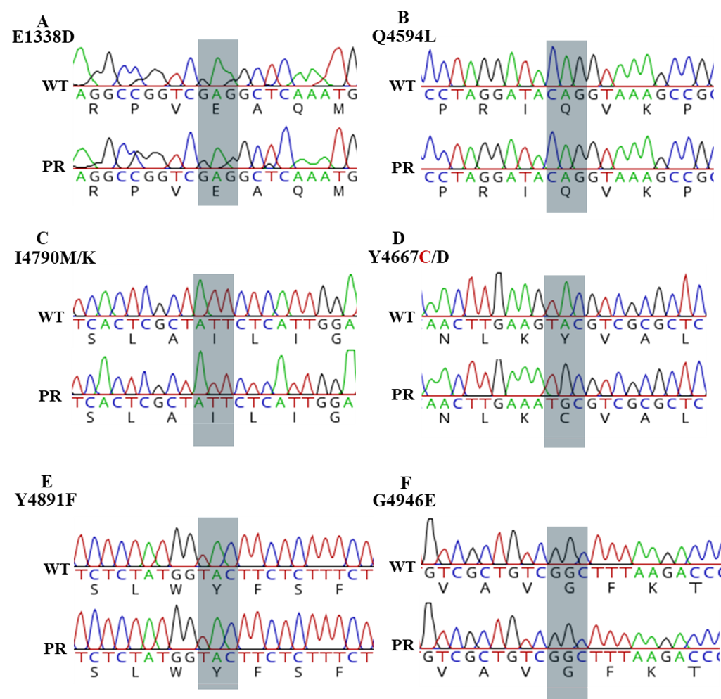

**Figure 2.** Chromatogram of the results of genotype screening of the PR21 population for RyR mutation sites associated with diamide resistance.

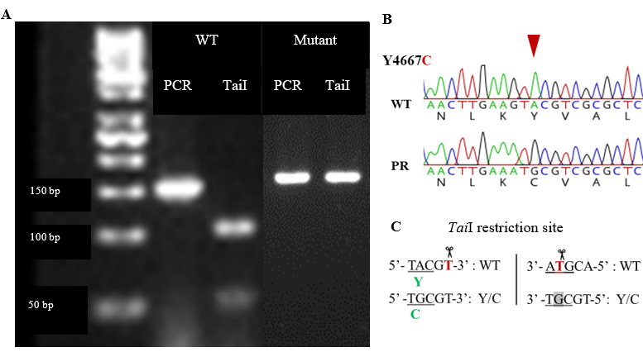

**Figure 3.** *Tai*I restriction enzyme digestion. *Tai*I restriction enzyme recognizes ACGT^ site and cuts best at 65°C in 10 minutes using a universal FastDigest Buffer. Isoschizomers: HpyCH4IV, MaeII. (A) The *Tai*I restriction enzyme digestion results on 4% agarose gel, (B) *Tai*I cut site in CincRyR, (C) FastDigest *Tai*Irestriction enzyme recognition pattern.

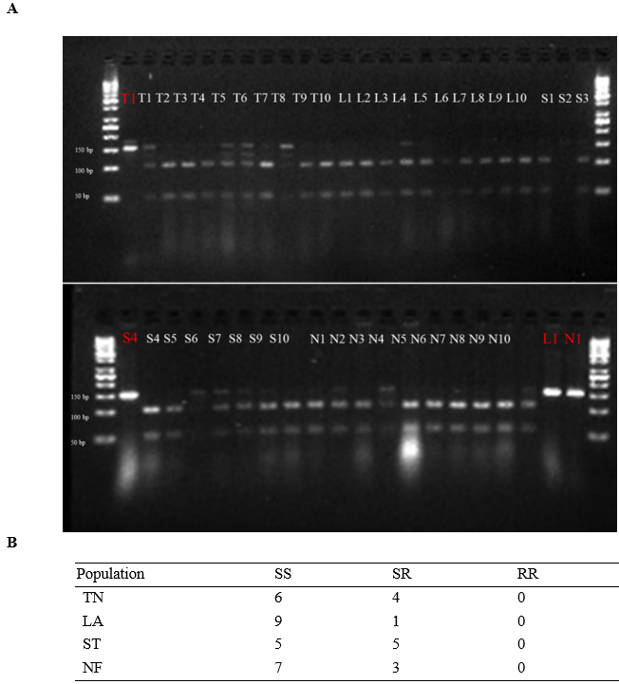

**Figure 4.** Y4667C mutation screening results of four field populations via *Tai*I restriction digestion. (A) A gel picture showing the results of the TaiI restriction digestion on 4% agarose gel. (B) Summary of the screening. Note: Samples in red are undigested PCR products used as a control to evaluate the efficacy of the digestion.

**Figure 5.** Gene counts of five detoxification gene families, which exhibited differential expressions in soybean looper.

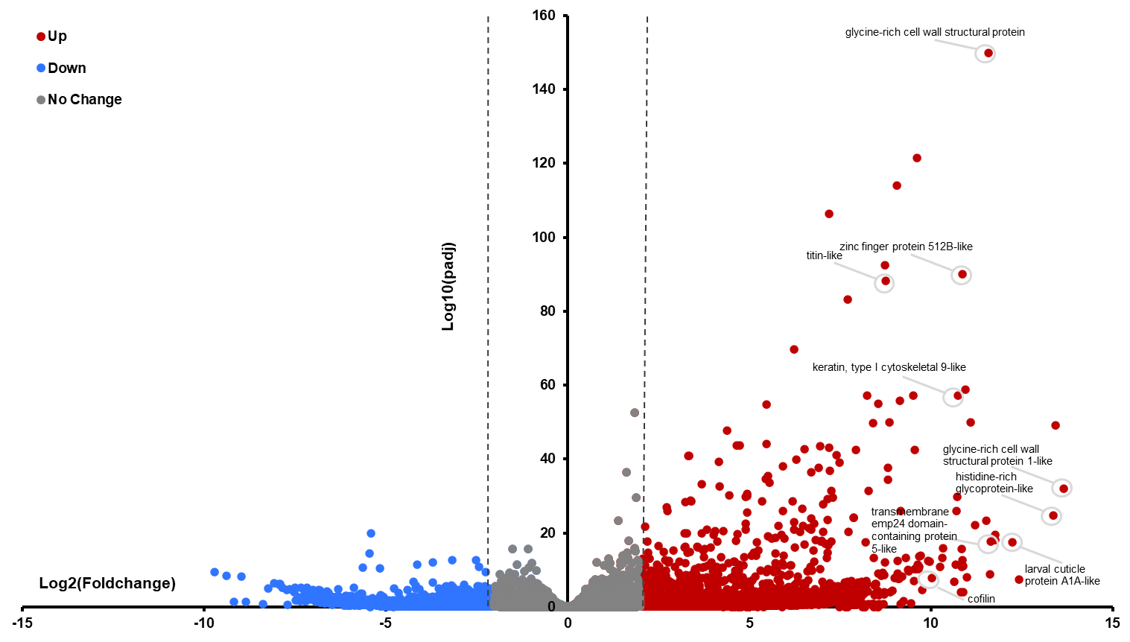

**Figure 6.** Volcano plot of differentially-expressed gene analysis. A sublethal chlorantraniliprole exposure (0.1 ppm for 48 hours) revealed that 2.5 times more genes were activated in the PR strain than in the susceptible strain.

**Figure 7.** Expression levels of CYP genes measured by qRT-PCR. CYP11051 showed significant difference between wild type and PR strains.

**Figure 8.** Eye color mutants identified in the G0 moths following CRISPR/Cas9‐mediated mutagenesis of *scarlet* in *Chrysodeixis includens*. (a) Representative image of a wild type (WT) moth with the normal eye color. (b) Nine putative mutants exhibiting distinct eye colors when compared with WT.

**Table 1.** Bioassay results of chlorantraniliprole on the lab and Puerto Rico (PR) strains of soybean looper.

|  |  |  |  |  |  |  |
| --- | --- | --- | --- | --- | --- | --- |
| Strain | Generation1 | *N*2 | LC50 (ppm) | FL 95%3 | Slope | RR4 |
| Lab | F20+ | 359 | 0.08 | 0.050-0.135 | 0.640 | - |
| PR21 | F3 | 120 | 0.88 | 0.151-2.015 | 0.614 | 10.0 |
| PR21 | F5 | 359 | 0.95 | 0.386-1.698 | 0.551 | 10.8 |
| PR24 | F2 | 514 | 0.12 | 0.067-0.219 | 0.601 | 1.5 |

1Number of generations in the laboratory when tested.

2Number of larvae tested to different concentrations of chlorantraniliprole.

395% fiducial limits.

4Resistance ratio (LC50 of PR strain/LC50 of Lab strain)

**Table 2.** Summary of screening of RyR mutation sites in the PR21 population

|  |  |  |  |
| --- | --- | --- | --- |
| Target | N* | Nm** | MR (%)*** |
| E1338 | 110 | 0 | 0 |
| Q4594 | 91 | 0 | 0 |
| Y4667 | 206 | 115 | 61 |
| I4790 | 206 | 0 | 0 |
| Y4891 | 206 | 0 | 0 |
| G4946 | 206 | 0 | 0 |

*N: Number of screened individuals

**Nm: Number of mutated individuals

***MR: Mutation ratio

**Table 3.** Summary of Y4667C screening in eight soybean looper populations.

|  |  |  |  |  |
| --- | --- | --- | --- | --- |
| SBL Population | SS | SR | RR | LC50 |
| LAB (F20+) | 1 | 16 | 0 | 0.09 |
| TN | 6 | 4 | 0 | - |
| LA | 9 | 1 | 0 | 0.23 |
| MS1 | 5 | 5 | 0 | 0.16 |
| MS2 | 7 | 3 | 0 | - |
| PR21 | 7 | 84 | 115 | 0.88 |
| PR24 (P1) | 3 | 1 | 5 | - |
| PR24mix (F2) | 0 | 15 | 5 | 0.12 |

**Table 4.** List of detoxification genes that were upregulated in the soybean looper larvae upon feeding on 0.1 ppm chlorantraniliprole.

|  |  |  |  |
| --- | --- | --- | --- |
| **Expression rank** | **Expression level (fold change)** | **Gene length (bp)** | **Gene description** |
| 1 | 9.55 | 1694 | cytochrome P450 9e2-like |
| 2 | 5.64 | 1759 | cytochrome P450 6a14 |
| 3 | 4.66 | 2942 | cytochrome P450 6B1-like |
| 4 | 3.68 | 334 | cytochrome P450 9e2-like |
| 5 | 3.35 | 1365 | glutathione S-transferase 1-like |
| 6 | 3.22 | 1472 | cytochrome P450 9e2-like |
| 7 | 2.71 | 952 | cytochrome P450 9e2-like |
| 8 | 2.39 | 1574 | UDP-glucuronosyltransferase 2B15-like |
| 9 | 2.14 | 974 | carboxylesterase B-1-like |
| 10 | 2.06 | 861 | glutathione S-transferase 1-like |
| 11 | 2.02 | 609 | glutathione S-transferase 1-like |