**Improving agronomic efficiency for Mississippi soybean producers**

**MSPB 44-2024 final report**

**March 24, 2025**

Michael J. Mulvaney, [mjm1166@msstate.edu](mailto:mjm1166@msstate.edu), (662)769-8436

Wes Lowe, wlowe@abe.msstate.edu, (662)325-7340

Corey Bryant, cjb777@msstate.edu, (870)723-0543

Vaughn Reed, vr401@msstate.edu, (270)608-1293

Jagmandeep Dhillon, [jagman.dhillon@msstate.edu](mailto:jagman.dhillon@msstate.edu), (662)325-2762

Oluwaseyi E. Olomitutu, [oeo20@msstate.edu](mailto:oeo20@msstate.edu), (662)370-7836

**Rationale/Justification for Research**

**Precision agriculture**

The benefits of using precision planters have been more widely documented in corn systems than soybean systems. Although we have demonstrated that we can successfully plant soybean at >9.5 mph, we want to make the technology available to those who plant into residue. Double-cropping systems are already late planting soybean, so mitigating yield loss by planting acreage quickly will reduce yield loss if we can find strategies to plant into high residue systems. Cover cropping systems should also benefit from faster planting for similar reasons, although they are not nearly planting as late as in double-cropping situations. Regardless, planting at high speed into residue is applicable to both cropping systems. Inadequate residue management can block furrow openers, thereby affecting furrow opening and closing and the consistency of seed placement (depth and spacing), potentially compromising seed-soil contact. Impaired seed-soil contact can result in poor germination, seedling emergence, crop establishment, and yield. To avoid poor seed-soil contact in residue systems, various row cleaners have been developed. They are designed to chop residues ahead and along the seed furrow, push residues to the side, or bury residues in a strip ahead of the furrow opener, or use a combination of the above. In addition, studies have shown that the efficacy of row cleaners is improved with increased planter speed but is influenced by row cleaner configuration. This study was proposed to launch an exploratory research effort to configure planters to adequately manage residue while planting soybean at high speeds.

**Improving grain quality with harvest management strategies**

Mississippi soybean producers are often docked for poor grain quality after harvest. Identifying the factors that contribute to poor grain quality requires many site-years of data. The United Soybean Board has partially funded a national effort to investigate management strategies that can improve grain quality. The project is implementing a common protocol in Mississippi so that we have statewide data to add to the national dataset. In addition, the project aims to identify suitable management strategies that enhance grain quality in Mississippi conditions. Experiments will examine desiccants and harvest date to protect yield and grain quality. We will conduct analyses on grain quality and composition as influenced by soybean management. Our team will establish experiments in 15 states across the U.S. to evaluate grain quality degradation (sprouting, green stem, green seed, protein, oil). Two separate trials are proposed in Mississippi. One will investigate desiccation timing and the other will investigate harvest timing. Both trials will utilize three maturity groups at two different planting dates.

**Fertility**

Fall-applied fertilizer is likely to have reduced nutrient use efficiency, resulting in greater fertilizer expense to soybean farmers compared to spring applications. The proposed trials will determine if P, K, and S fertilizer rates can be reduced when spring-applied compared to fall-applied as well as refine rate recommendations. These trials provide an excellent opportunity to determine if soil test lab recommendations are keeping pace with modern soybean production goals in Mississippi. To that end, we will use these trials to begin collecting data to determine if statewide soil test correlation and calibration data, as well as the resulting recommendations they produce, require updating for soybean P, K, and S response. We will utilize both Mehlich 3 and Lancaster extractants in order to compare the most common soil test procedures and refine correlation and calibration data used to make fertilizer recommendations.

**Cover crop management effects on soybean establishment and bed stability**

Barriers to management of cover crops include establishment in furrow irrigated (bedded) systems and interference of cover crop residue during soybean planting. Prior to launching detailed investigations into the response of soybean due to cover crops, we have opted to first determine optimal methods of cover crop establishment before looking at other cover crop management practices, such as mixes, termination, and timing, and plant and soil responses to those practices. We reason that we must develop good methods to establish cover crops in bedded systems before we can begin further work on those systems. The main question of interest is how soybean responds to different cover crop establishment practices. Cover crops may be spatially arranged in bedded systems to either increase or decrease the amount of residue that remains on the bed, which should affect soybean planting the following spring. We propose to broadcast cover crop seed before or after fall bedding to see if the resulting spatial arrangement of residue can facilitate subsequent soybean planting and establishment. We have also developed a prototype combine-mounted broadcast seeder, which is mounted behind the soybean combine to broadcast cover crop seed with soybean residue during harvest. The advantage of this scenario is that cover crop seed would then be covered by soybean residue, facilitating planting and establishment of cover crops without the need for an additional pass to plant the cover crop. This system for cover crop establishment has never before been tested in soybean systems.

**OBJECTIVES:**

Objective 1: To increase planting speed into residue.

Objective 2: Identify harvest management strategies to improve grain quality.

Objective 3: To increase fertilizer use efficiency.

Objective 4: Develop strategies to improve cover crop management in soybean systems.

**Report of Progress/Activity**

**Objective 1:**

This trial was implemented in Brooksville, MS. Elbon rye was broadcasted at 60 lbs/ac in November 2023. Aerial application of nitrogen (60 unit/ac) was done on February 21, 2022. Rye was burned down on April 24, 2024, four weeks before soybean planting. A John Deere® 6R130 tractor with 130 horsepower was used to operate 4-rows unit precision planter (John Deere® toolbar with MaxEmerge 2 row units retrofitted with AgLeader® SureSpeed and SureForce). The planter was fit with Martin-Till 1345 narrow row cleaners with razor wheels. Planting was conducted into 7,000 lbs/ac (dry matter basis) standing rye residue. The experimental design was a 2 × 8 factorial laid out in a randomized complete block design, replicated four times. Planting was accomplished at two planting speeds (5 and 10 mph) and eight row cleaner configurations (row cleaner alone, row cleaner plus side treader wheels, wheel weights, and coulter attachments in all possible combinations). Plots were 25.3 × 1000 ft long. Soybean variety Revere 4526XFS was planted at 140,000 seeds/ac. Plots were planted as a ‘strip trial,’ *i.e.*, a single planter pass for each treatment. Data were collected on plant population and plant spacing. Surface and subsurface residue were collected immediately after planting. Plant spacing variability and yield were estimated. Analysis of variance (ANOVA) was computed for traits using the lmerTest package of R. Means were separated at an alpha value of 0.05 LSD due to lack of significant interaction.

The results indicate that there was no significant effect of speed × row cleaner configurations or row cleaner configurations on all measured parameters (Table 1). However, planting speed did affect plant stand, plant spacing and spacing variability Increased planting speed significantly increased in-row spacing variability and lowered plant populations (Figure 1 - Figure **3**). Despite these effects on plant spacing and population, yield was unaffected by planting speed. The non-uniformity in plant stand and spacing with increased planting speed is not peculiar to residue systems alone, as we have reported similar trends in conventional tilled fields. These findings suggest that soybean growers can plant into a high residue system using the simplest and cheapest row cleaner configuration without yield penalties, even at higher planting speeds.

**Objective 2:**

Two different trails have been implemented at the R. R. Foil Plant Science Research Center, Starkville, MS. The first was a planting date × maturity group × desiccation time and the second was a planting date × maturity group × harvest date trial. Both trials were planted at two locations. The experimental design was 2 × 3 × 3 factorial laid out in a randomized complete block design, replicated four times. Plots were 25.3 × 35 ft long. Data were collected on green stem ratings, green plant material ratings and seed quality and composition. Yield was estimated at harvest.

**Planting date × maturity group × desiccation time**

Maturity group 3.9 demonstrated the lowest green stem (Figure 4). Maturity group 4.5 showed moderate green stem, with ratings falling between MG 3.9 and 5.0, and maintained relatively consistent performance between North Farm and Ramsey locations. Late planting dates resulted in less green stem compared to early planting dates. Desiccant timing at R7 demonstrated reduced green stem across both locations compared to R6.5 application timings, suggesting potential benefits for harvest management. No significant effects were observed at North Farm for any factor or interaction (P > 0.05) (Table 2). At Ramsey, the significant MG × planting date interaction indicates that yield response to planting date varied depending on the maturity group selection.

**Planting date × maturity group × harvest date**

MG 3.9 exhibited higher green stem ratings compared to MG 4.5and 5.0, particularly at North Farm (Figure 5). Early planting dates showed elevated green stem at both locations compared to late plantings in North Farm consistently displaying higher values. Late harvest timing resulted in the lowest green stem ratings compared to early harvest across locations. The optimal harvest showed intermediate green stem ratings suggesting a potential management window for balancing harvest efficiency.

Harvest stage significantly impacted losses at North Farm (Table 3). Ramsey showed more complex interactions with significant effects for harvest stage, MG × planting date, and planting date × harvest stage interactions. This suggests harvest timing optimization is crucial but must be balanced with maturity group and planting date at that location, which was non-irrigated. North Farm yield was influenced by planting date and MG × planting date × harvest stage interaction, while Ramsey showed significance only for MG × planting date interaction.

**Objective 3:**

Trials were planted at three Mississippi State University research stations located in Brooksville, Starkville, and Stoneville. Prior to experiment initiation, soils were identified to be deficient in each nutrient. Three trials were implemented, one for each nutrient: P, K, and S. P2O5 was applied as triple super phosphate at 0, 30, 60, 90, and 120 lbs/ac, K2O was applied as potash at 0, 60, 120, 180, and 240 lbs/ac, and S was applied as elemental sulfur at 0, 10, 20, 30, and 40 lbs/ac. Both fall- and spring-applied fertilizer treatments were broadcast, followed by hipping to incorporate the fertilizer. The trials were laid out in a randomized complete block design with four replications. Plot size was 3.17 × ≥35 ft long. Data were collected on stand count, R4 plant tissue sample for P, K and S, grain yield, and grain nutrient content analysis.

Statistical differences were found for phosphorus concentrations in R5 leaf tissue samples at both Brooksville and Stoneville, with later applications (Fall-90lbs through Spring-120lbs) showing higher P concentrations at Stoneville (Figures 6 & 7). Statistical differences in grain P concentration were only observed at the Brooksville location (Figures 8 & 9). Potassium concentrations showed statistical differences in both leaf tissue and grain at Starkville, with the greatest differences observed between control/lower rates versus higher fertility rates (Figures 10 & 11). Sulfur concentrations in leaf tissue showed statistical differences at both locations with no consistent pattern across treatments (Figures 12 $ 13). Similarly, grain S concentrations at Brooksville showed statistical differences but no clear optimal rate or timing (Figure 14). There were no yield differences across sites regardless of application rate or timing, suggesting critical soil test values may require revision, since all sites were selected based on deficient nutrients of interest (data not shown).

**Objective 4:**

The trail was planted at the R. R. Foil Plant Science Research Center in Starkville, MS. This study consists of five treatments (1. A no wheat control, 2. Wheat broadcast followed by hipping, 3. Hipping followed by broadcast wheat, 4. Hipping followed by drilling, and 5. Combine seeder followed by hipping) laid out as a randomized complete block design with four replications. Wheat was broadcasted at the rate of 60 lbs/ac. Plots were 3.17 × 49 ft long. Bed height was measured after hipping and after two major rain events. Data were recorded on bed height, soil moisture during the season and after harvest, wheat and soybean stand count, wheat biomass. Grain yield was estimated at harvest.

Post-emergence soybean stand count and yield results indicated no significant differences among treatments (Figure **15** $ **16**). Bed height remained consistent across treatments except for hip-then-drill treatment, which showed lower height due to initial drill impact on the bed (Figure 17). For cover crop (wheat) stand counts, combine-hip produced the highest counts on beds, while broadcast-hip performed moderately, and hip-broadcast showed the poorest stand (Figure 18). Furrow stand counts followed a similar pattern, with hip-broadcast showing significantly lower counts (Figure 19).

**Impacts and Benefits to Mississippi Soybean Producers**

Producers can confidently plant at speeds up to 10 mph into high-residue systems without yield penalties, using even basic row cleaner configurations. This enables faster completion of planting during optimal windows, especially important for double-cropping systems, reducing costs while maintaining productivity.

The identification of optimal maturity group, planting date, and harvest timing combinations provides practical strategies to minimize green stem issues and maximize grain quality. Later planting dates and R7 desiccation timing were particularly effective, giving producers specific management tactics to avoid quality discounts at delivery.

Results from fertilizer efficiency trial suggest greater flexibility in fertilizer application timing than previously thought, as neither fall nor spring applications showed yield advantages. For cover crop integration solutions, the success of the combine-mounted seeder for establishing cover crops eliminates an additional field pass, reducing fuel, labor, and equipment costs. Producers now have validated options for integrating cover crops into bedded systems without compromising subsequent soybean performance or bed stability, supporting sustainable production practices.

**End Products–Completed or Forthcoming**

*Completed*

1. Olomitutu, O. E., Mulvaney, M. J., Lowe, J. W., Bryant, C. J., Wallace, J., Harper, N., ... & Dhillon, J. (2024). Soybean response to high‐speed planting in Mississippi. Agronomy Journal, 116(6), 2817-2826. <https://doi.org/10.1002/agj2.21665>.
2. Shavers, G. M., Olomitutu, O. E., Hilyer, T., Bryant, C. J., Mulvaney, M. J., Reed, V., Oyedele, O., & Lowe, W. J. (2024) Soybean Response to Fertility Timing in Mississippi [Abstract]. ASA, CSSA, SSSA International Annual Meeting, San Antonio, TX. <https://scisoc.confex.com/scisoc/2024am/meetingapp.cgi/Paper/160801>.
3. Shavers, G. M., Mulvaney, M. J., Wallace, J., Hilyer, T., Olomitutu, O. E., Oyedele, O., Bryant, C. J., Reed, V., & Lowe, W. J. (2024) Determining Effective Cover Crop Establishment Methods in Bedded Systems [Abstract]. ASA, CSSA, SSSA International Annual Meeting, San Antonio, TX. <https://scisoc.confex.com/scisoc/2024am/meetingapp.cgi/Paper/161616>.
4. Olomitutu, O. E., Mulvaney, M. J., Lowe, W. J., Wallace, J., Bryant, C. J., Shavers, G. M., Hilyer, T., Meadows, J., Dhillon, J. S., Larson, E. J., Zhang, J., & Oyedele, O. (2024) High-Speed Soybean Planting into Heavy Residue [Abstract]. ASA, CSSA, SSSA International Annual Meeting, San Antonio, TX. <https://scisoc.confex.com/scisoc/2024am/meetingapp.cgi/Paper/158479>.
5. Lowrey, H. V., Mulvaney, M. J., Wallace, J., Hilyer, T., Olomitutu, O. E., Shavers, G. M., Oyedele, O. (2025). Planting Date by Maturity Group Effects on Soybean Architecture and Yield Components in Mississippi. ASA-CSSA-SSSA International Annual Meeting, Westin Irving Convention Center, TX, Feb. 01- Feb. 04, 2025.
6. Shavers, G. M., Mulvaney, M. J., Wallace, J., Hilyer, T., Olomitutu, O. E., Oyedele, O., Bryant, C. J., Reed, V., & Lowe, W. J. (2025). Establishing Cover Crops in a Bedded Cropping System. ASA-CSSA-SSSA International Annual Meeting, Westin Irving Convention Center, TX, Feb. 01- Feb. 04, 2025.
7. Shavers, G. M., Olomitutu, O. E., Hilyer, T., Bryant, C. J., Mulvaney, M. J., Reed, V., Oyedele, O., & Lowe, W. J. (2025) Impact of Fertility Timing in Soybean. ASA-CSSA SSSA International Annual Meeting, Westin Irving Convention Center, TX, Feb. 01- Feb. 04, 2025.
8. Olomitutu, O. E., Mulvaney, M. J., Lowe, W. J., Wallace, J., Bryant, C. J., Shavers, G. M., Hilyer, T., Meadows, J., Dhillon, J., Larson, E. J., Zhang, J., & Oyedele, O. (2025). Row Cleaner Configurations to Facilitate High-Speed Soybean Planting into Residue. ASA-CSSA-SSSA International Annual Meeting, Westin Irving Convention Center, TX, Feb. 01- Feb. 04, 2025.

*Forthcoming*

The following products are anticipated:

1. MS Thesis, Shavers, G. M.
2. PhD. Thesis, Olomitutu, O. E.
3. Peer-reviewed publications, Agronomy Journal in 2025/2026.

Future research questions that may be addressed in the future include:

1. Can faster speeds make growers more resilient to climate change?
2. If we can get more even stands, can we reduce seed rates?
3. Which components of advanced planting technology are necessary for soybean production, and which are unnecessary?
4. Are salts in irrigation water limiting soybean production in Mississippi?

Two graduate students are being trained on this, and findings from this project will be presented in extension talks, bulletins, posters, presentations, and peer-reviewed publications.

**Table 1. ANOVA of Rye surface and subsurface residue, soybean plant stand, plant spacing, spacing variability and yield response to planting speed and row cleaner configurations.**

|  |  |  |  |  |  |  |  |
| --- | --- | --- | --- | --- | --- | --- | --- |
| Factors | DF | Surface residue (lb/ac) | Subsurface residue (lb/ac) | Plant stand (ac-1) | Plant spacing (in) | Spacing variability (in) | Yield (bu/ac) |
| Speed | 1 | 0.4727 | 0.2786 | 0.02156 | 0.01064 | 0.02628 | 0.6169 |
| Configuration | 7 | 0.9538 | 0.9296 | 0.79698 | 0.73785 | 0.75537 | 0.1592 |
| Speed × Configuration | 7 | 0.6605 | 0.7138 | 0.92856 | 0.95842 | 0.94325 | 0.1090 |

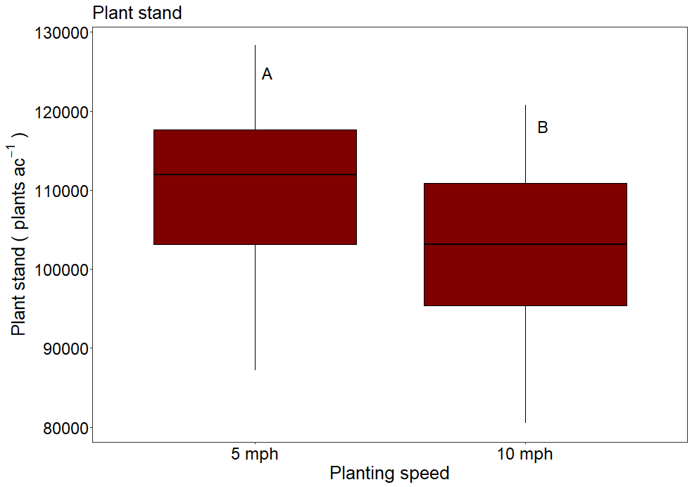

**Figure 1. Soybean stand using** **at 5 and 10 mph planting speeds.** **Different letters above means indicate significantly different response (LSD = p<0.05).**

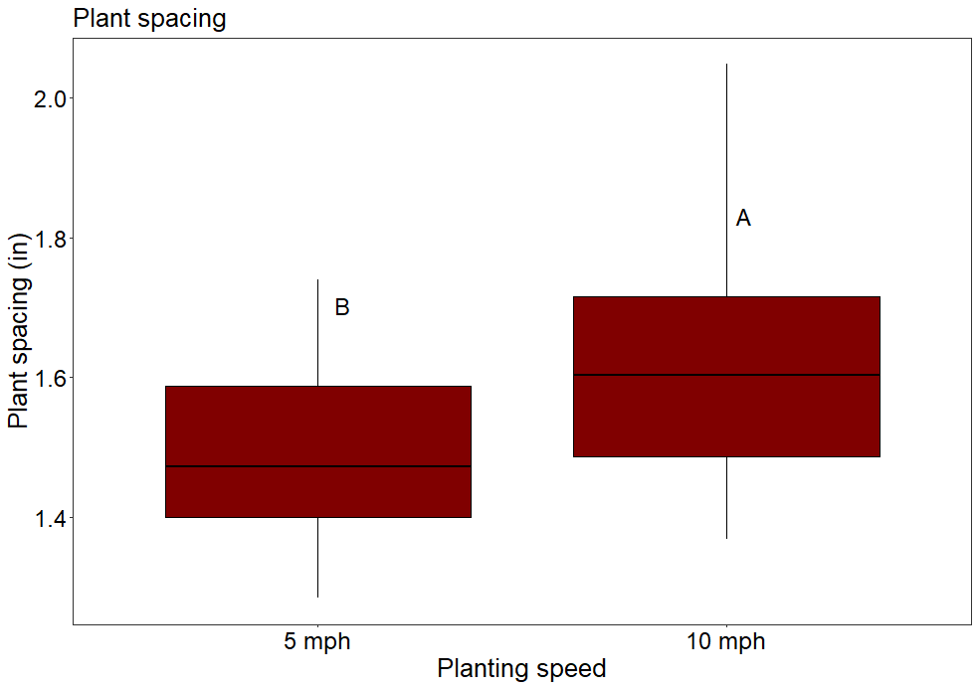

**Figure 2. In-row plant spacing** **at 5 and 10 mph planting speeds. Different letters above means indicate significantly different response (LSD = p<0.05).**

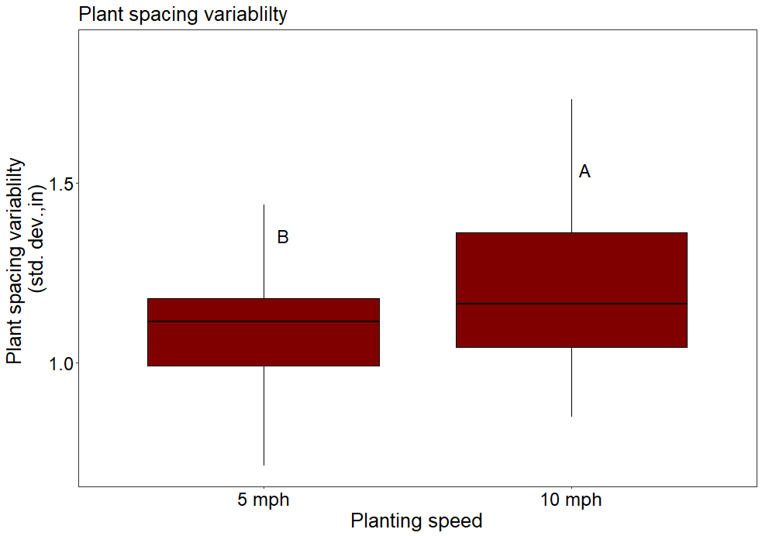

**Figure 3. In-row plant spacing standard deviation at 5 and 10 mph planting speeds. Different letters above means indicate significantly different response (LSD = p<0.05).**

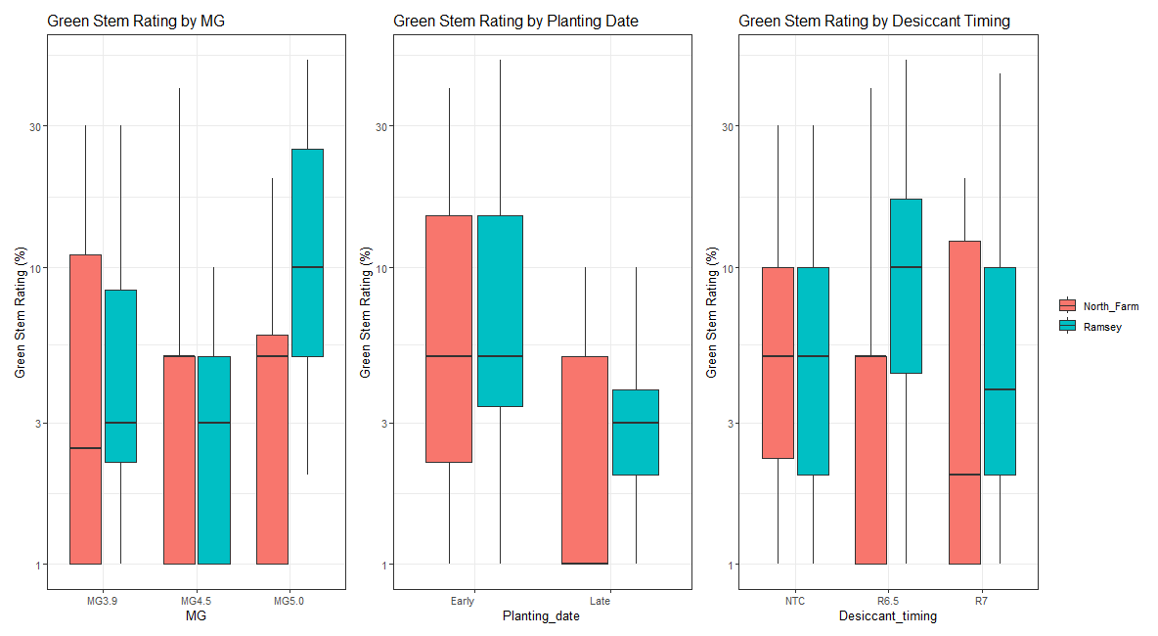

**Figure 4. Green Stem Rating Comparison in** **Soybean for the effects of Maturity Group, Planting Date, and Desiccant Timing at North Farm and Ramsey in 2024.**

**Table 2. ANOVA of yield response to soybean for the effects of Maturity Group, Planting Date, and Desiccant Timing at North Farm and Ramsey in 2024.**

|  |  |  |  |
| --- | --- | --- | --- |
| Factors | DF | North Farm | Ramsey |
| MG | 2 | 0.92483 | 0.97168 |
| Planting date | 1 | 0.06579 | 0.93517 |
| Desiccant timing | 2 | 0.34997 | 0.52220 |
| MG × Planting date | 2 | 0.50764 | 0.01344 |
| MG × Desiccant timing | 4 | 0.69520 | 0.77259 |
| Planting date × Desiccant timing | 2 | 0.41151 | 0.03325 |
| MG × Planting date × Desiccant timing | 4 | 0.91516 | 0.25074 |

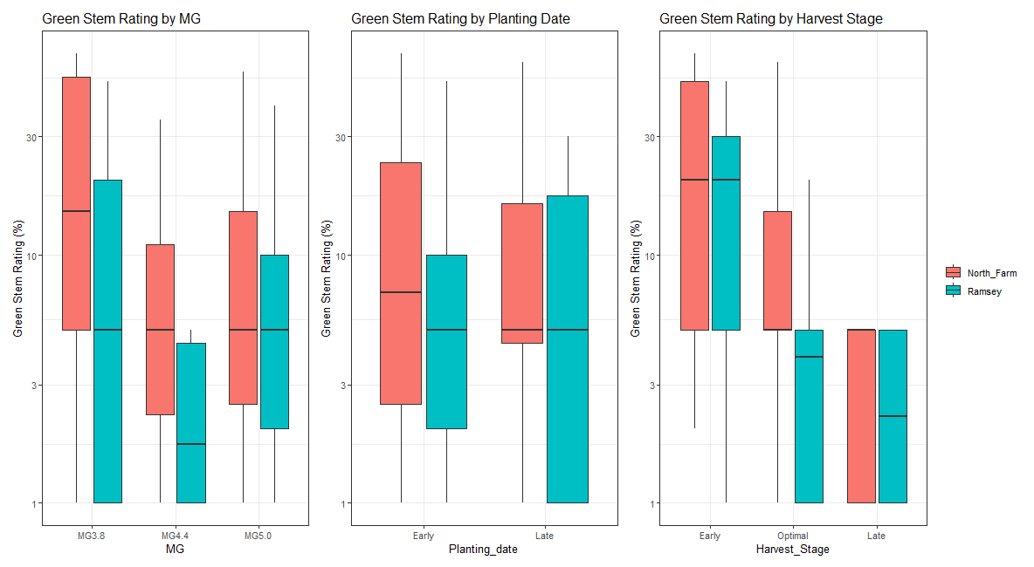

**Figure 5. Green stem rating comparison in soybean for the effects of maturity group, planting date, and harvest timing at North farm and Ramsey in 2024.**

**Table 3. ANOVA of yield response to Soybean for the effects of Maturity Group, Planting Date, and Harvest Timing at North Farm and Ramsey in 2024.**

|  |  |  |  |  |  |
| --- | --- | --- | --- | --- | --- |
|  |  | North Farm | | Ramsey | |
| Factors | DF | Harvest lost | Yield | Harvest lost | Yield |
| MG | 2 | 0.249594 | 0.45293 | 0.986797 | 0.3703 |
| Planting date | 1 | 0.788949 | 0.01178 | 0.245178 | 0.4432 |
| Harvest stage | 2 | 0.000184 | 0.23026 | 0.000630 | 0.6021 |
| MG × Planting date | 2 | 0.655338 | 0.03974 | 0.000014 | 0.0497 |
| MG × Harvest Stage | 4 | 0.431518 | 0.77683 | 0.007275 | 0.2319 |
| Planting date × Harvest stage | 2 | 0.352843 | 0.80991 | 0.001548 | 0.7597 |
| MG × Planting date × Harvest Stage | 4 | 0.772222 | 0.02876 | 0.547258 | 0.5554 |

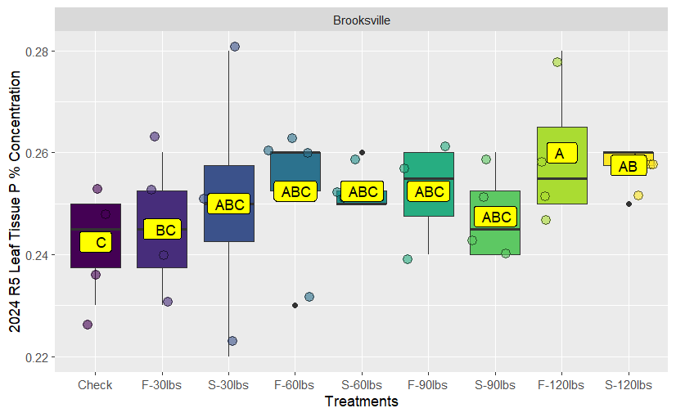

**Figure 6. R5 plant tissue phosphorus (P) percentage comparing different rates and fertility timing in Brooksville. Different letters above means indicate significantly different responses (LSD= p<0.05).**

**Figure 7. R5 plant tissue P percentage comparing different rates and fertility timing in Stoneville. Different letters above means indicate significantly different responses (LSD= p<0.05).**

**Figure 8. Grain sample P percentage comparing different rates and fertility timing in Brooksville. Different letters above means indicate significantly different responses (LSD= p<0.05).**

**Figure 9. Grain sample P percentage comparing different rates and fertility timing in Stoneville. Different letters above means indicate significantly different responses (LSD= p<0.05).**

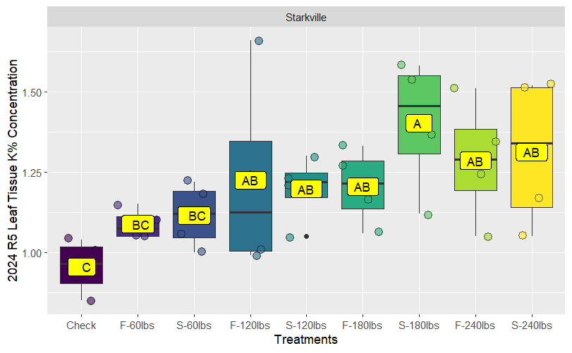

**Figure 10. R5 plant tissue potassium (K) percentage comparing different rates and fertility timing in Stoneville. Different letters above means indicate significantly different responses (LSD= p<0.05).**

**Figure 11. Grain sample K percentage analysis comparing different rates and fertility timing in the Starkville location. Different letters above means indicate significantly different response (LSD= p<0.05).**

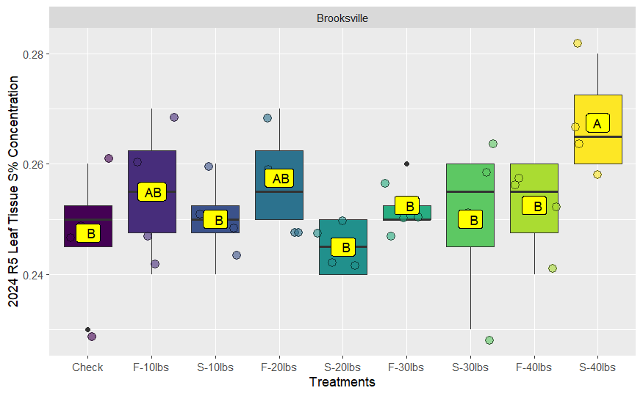

**Figure 12. R5 plant tissue S percentage comparing different rates and fertility timing in Stoneville. Different letters above means indicate significantly different responses (LSD= p<0.05).**

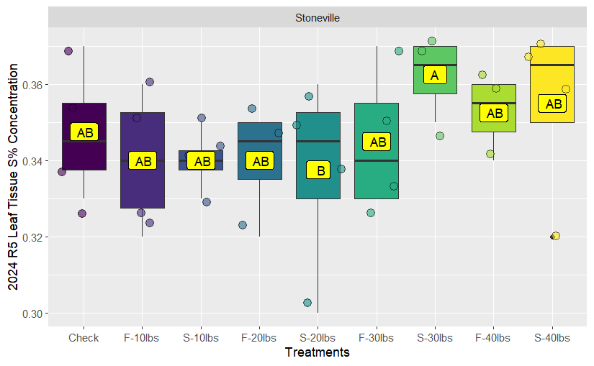

**Figure 13. R5 plant tissue S percentage comparing different rates and fertility timing in Stoneville. Different letters above means indicate significantly different responses (LSD= p<0.05).**

**Figure 14. Grain sample Sulfur (S) percentage comparing different rates and fertility timing in Brooksville. Different letters above means indicate significantly different responses (LSD= p<0.05).**

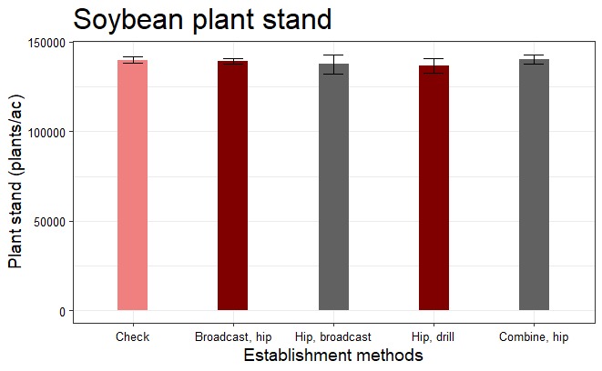

**Figure 15. Soybean plant stand response to different cover crop establishment strategies. No significant difference responses found (LSD= p<0.05).**

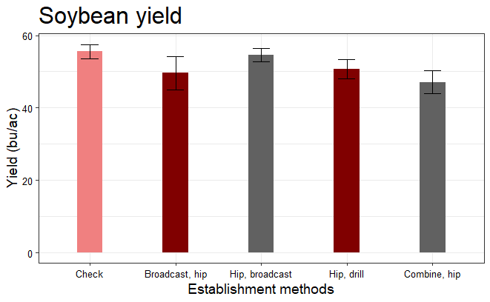

**Figure 16. Soybean yield response to different cover crop establishment strategies. No significant difference responses found (LSD= p<0.05).**

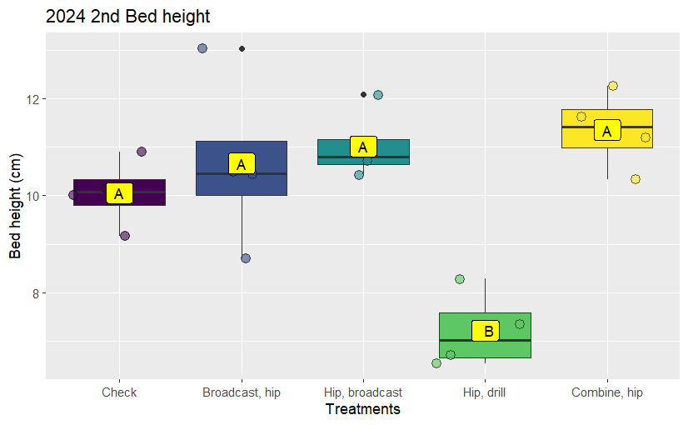

**Figure 17. Bed height stability response to different cover crop incorporation method into a bedded system. Different letters above means indicate significantly different response (LSD= p<0.05).**

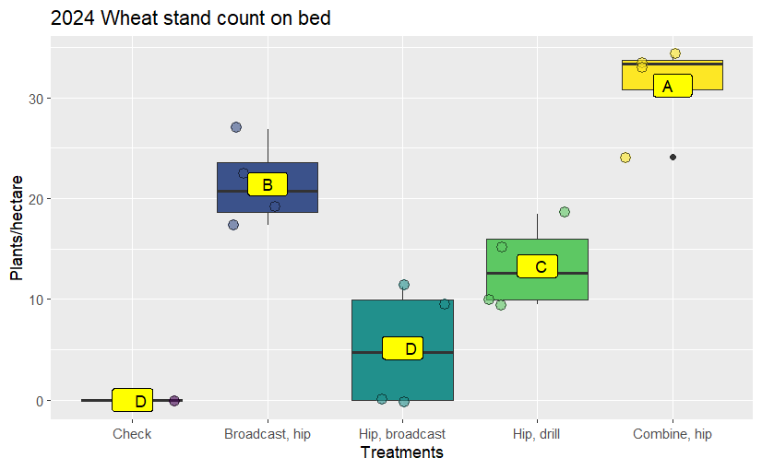

**Figure 18. Wheat stand count on the bed comparing different cover crop incorporation method into a bedded system. Different letters above means indicate significantly different response (LSD= p<0.05).**

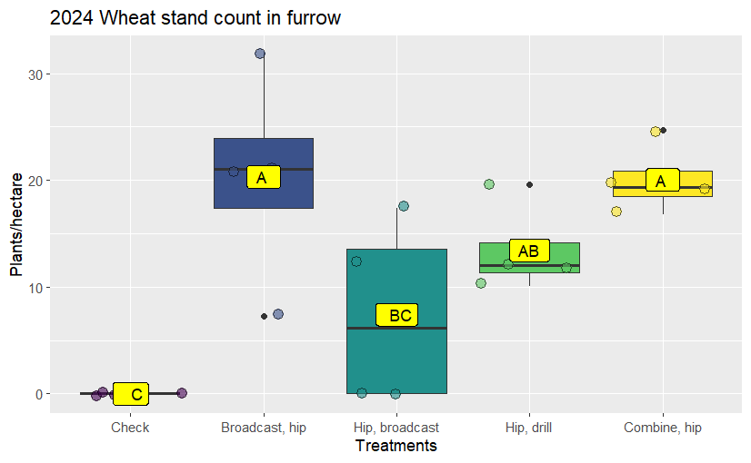

**Figure 19. Wheat stand count in the furrow comparing different cover crop incorporation method into a bedded system. Different letters above means indicate significantly different response (LSD= p<0.05).**