MSPB Project 49-2024: Sampling Soybean Insects Using DINSS (Drone Insect Net Sampling System)
Final Report

Fred Musser, fm61@msstate.edu, 662-722-8281
Bryan Whittenton, jbw373@msstate.edu, 662-325-6949
Gene Merkl, gm53@msstate.edu, 662-325-5829
Tyler Towles, tt305@msstate.edu, 662-820-4217
William “Covey” Lockhart, wcl126@msstate.edu, 601-832-3464

Background
Insect scouting in soybeans is needed throughout the growing season but is time consuming and labor-intensive. When soybeans are tall, soils are wet, or soybeans are planted in narrow rows, walking through these fields can be difficult. The development of drone technology may present an opportunity for increasing the efficiency of scouting insects. Research initiated during 2019 led to a 12” diameter sweep net hung below a drone on a spring-loaded arm, called the Drone Insect Net Sampling System (DINSS). This tool was selected based on our ability to use it consistently while minimizing crashes. Comparisons of DINSS to manual sweep net and drop cloth sampling methods during 2020 and 2021 under a previous MSPB grant showed that DINSS captured fewer insects per sample than manual drop cloth or sweep net sampling , but there were strong correlations among sampling methods for all the insect pests monitored. Based on these experiences, some modifications were recommended to increase insect catch rate without sacrificing drone stability. These modifications are expected to reduce the number of samples required to make a management decision, thereby improving the efficiency of DINSS.
While the data suggest that DINSS can be used effectively in soybeans, all data were collected with a single drone flown by a single pilot. Furthermore, all the sampled fields were planted in wide rows and most insect densities were well below threshold. Before broadly recommending DINSS, data collected with a broader array of drones and pilots are needed to establish thresholds that can be used with confidence under a broad range of conditions. In addition to confirming research over a wider range of conditions, modifications of DINSS should be explored to see if efficiency can be increased by catching more insects per sample. Lastly, incorporation of defoliation imagery captured by the drone into DINSS is needed to make a complete insect management recommendation.
Objectives
- Test modifications of the current DINSS to increase insect counts per sample and decrease the number of samples required to make a management decision.
- Validate DINSS with multiple drones and drone pilots in a wide variety of field situations.
- Compare cost and time required to make management decisions using drone-collected defoliation images plus DINSS data versus manual estimates of defoliation plus conventional sweep net data.
Report of Progress/Activity
Objective 1: Test modifications of DINSS.
Two modifications to DINSS were tested during 2023. The first was using a 15-inch diameter sweep net vs. the 12-inch net used previously. The second modification was the addition of a second spring attachment that provided more tension on the attachment so that the net would remain more vertical when being pulled through soybeans. We purchased a larger drone (DJI Matrice 350 RTK) to conduct this research. Insect data were collected using the following versions of DINSS:
- D1-12: Drone with a 12-inch sweep net and a single-spring tension apparatus (original DINSS)
- D1-15: Drone with a 15-inch sweep net and a single-spring tension apparatus
- D2-12: Drone with a 12-inch sweep net and a double-spring tension apparatus
- D2-15: Drone with a 15-inch sweep net and a double-spring tension apparatus
- Control: Manual sweep net
Nineteen soybean fields were sampled by all 5 methods with 4 samples collected by each method in each field. Each DINSS sample was done with the DJI Matrice 350 RTK drone flown 50-meters across rows at a constant speed of 4-meters per second. A control sample consisted of 25 sweeps with a manual sweep net. Each sample was collected from a different part of the field to minimize any impact of one sample on other samples. The contents of each sample were placed in a plastic bag and frozen. Insects were later identified and counted in the lab. Data were analyzed by making correlations between the 4 DINSS methods and the manual sampling method.
In the analysis of three-cornered alfalfa hoppers, no DINSS configuration was significantly different than another at the manual sweep net threshold of 100/25 sweeps (Fig. 1). The correlation estimated a threshold of between 25 and 28 threecornered alfalfa hoppers per 50-m sample for all four DINSS configurations. For Lepidoptera (Fig. 2), insect densities were low, and no fields were sampled that were near the threshold of 38 larvae/25 sweeps. While extrapolating the estimated correlation lines to the threshold would suggest that the D2-15 configuration would have a different threshold than the other configurations, this conclusion cannot be made without data at higher densities. The trend of no important difference in predicted threshold was also observed for redbanded stink bug and for the overall stink bug complex (Fig. 3, 4).
These results were unexpected, especially for the bigger sweep net. The reasons for no additional insects captured even though a larger area was sampled are unknown. Perhaps the speed of the drone was too slow, allowing insects to fly out of the net, with more flying out of the larger net. However, there was no noticeable difference in catch efficiency between highly mobile insects like threecornered alfalfa hopper and less mobile insects like stink bug nymphs, which would be expected if this were the cause. Another explanation may be that the larger net was not flown as deep into the canopy, so the actual area sampled was not much different. Given the same pilots flew both configurations, this seems implausible. The negative side of our finding is that no modification increased the efficiency of sampling with DINSS. The positive side of this result is that the recommended threshold is not very sensitive to the specific DINSS configuration being used.
Objective 2: Validate DINSS with multiple UAVs and pilots.
Sixty-five total fields were sampled during 2024 within this objective; eight of which had a single pilot with two UAVs, two of which had two pilots and two UAVs, and 55 of which had multiple pilots with one UAV. The two UAVs used were the DJI Matrice 350 RTK and the DJI Matrice 100. The D2-12 two spring system was utilized as the DINSS system for 2024 (D2-12). DINSS samples were 50-m 4m/s flights perpendicular to the rows as done during 2023. Four samples of each treatment by each pilot, including the manual sweep net, were collected from each field. Efforts were made to maintain the same speed, distance, and drone height above the crop canopy by both pilots to achieve uniformity in sampling.
As has been observed by others, the rate of insect collection varied significantly between samplers using a manual sweep net, as demonstrated with data for threecornered alfalfa hopper (Fig. 5) and kudzu bugs (Fig. 6), where LRG collected approximately 1/3 the number of insects as WCL in spite of being trained on how to use the sweep net. A similar difference between samplers was observed when the “sampler” was the pilot using DINSS, as demonstrated with a comparison of the number of kudzu bug nymphs (Fig. 7) and the combination of green cloverworm and velvetbean caterpillar (Fig. 8) collected by WCL and LRG. In both cases LRG caught approximately 50% as many insects as WCL. Lastly, the UAV carrying DINSS made a significant difference in insect capture rate, even when controlling for pilot. A comparison of the number of green cloverworms and velvetbean caterpillars (Fig. 9) and kudzu bug nymphs (Fig. 10) collected by WCL using the same D2-12 DINSS configuration attached to either the M100 or the M350 UAV showed the M100 only collected about 60% as many insects as the M350.
Results reflect that pilot and the choice of UAV affects DINSS insect capture rates in soybeans. The DINSS system was expected to reduce variability in insect counts compared to a manual sweep net due to the lack of the sweeping motion on the DINSS, however variability was observed between pilots at a rate comparable to the manual differences. Previous research had attributed sampler bias to the angle at which the net penetrates the plant canopy, the force of impact, the speed of the net through the canopy, and the strength of an individual. While a pilot cannot alter these attributes using DINSS, the impact of pilot persisted. While there were no obvious differences in methodology between pilots, there were significant differences in insect capture rates. Perhaps speed, height and drone pitch varied between pilots. Additionally, the manner in which a pilot returned the aircraft to the homing location as well as how the pilot lifted the net out of the canopy once the 50 m flight was completed may have affected the retention rate of insects collected. Pilot experience may also account for some variability when sampling. While all pilots were licensed FAA Part 107 remote pilots, experience flying UAVs at low altitude as done with DINSS was variable.
The differences in insect capture rate between the two UAVs tested during this research were likely due to payload capacity differences. The total weight of the DINSS system was within factory specifications for maximum takeoff payload capacity for both aircrafts, but the larger DJI Matrice 350 RTK was easier to fly at a constant height above the plant canopy with DINSS attached, so it was overall the more user friendly option. It consistently picked up more insects per sample compared to the DJI Matrice 100 even though both were equipped with the same DINSS.
Objective 3: Compare cost and time of DINSS with defoliation images and manual sampling
Samplers visually assessed the level of leaf defoliation in each field. A DJI Matrice 350 RTK equipped with a DJI Zenmuse H20 camera was also flown to areas of the field and adjusted via the radio transmitter so that defoliation was visible. The shooting angle and the height above the canopy varied within the time of day and weather conditions. The UAV was not equipped with a sensor to measure the height above the canopy. Rather, the radio transmitter displayed the altitude above or below where lift off occurred. Based on these data it is estimated that ideal imagery capture for estimating defoliation ranged from two to five meters above the crop canopy. At this altitude, the level of defoliation in the canopy can be estimated as easily from images as from physically walking through the field (Fig. 11, 12). Images can be taken at higher altitudes, but estimating defoliation requires the user to “zoom in” on the image to estimate the level of defoliation.
The time required to complete sampling was recorded for both DINSS and manual sampling methods. For manual sweep net sampling, the sampler started a timer before stepping into the field and stopped the timer upon exiting after collecting and bagging four sets of 25 sweeps. For DINSS sampling, the timer was started at lift off and ended when the fourth subsample of each set was bagged. This protocol only captured “actual time of sampling” for both methods. Assembly, disasembly, and changing batteries for DINSS were excluded from the recorded sampling time. Average times from both years and all samplers suggest that while DINSS sampling is a relatively quick sampling method, it is not quite as rapid as the manual sweep net method. For all samplers, the manual sweep net was 1-2 minutes quicker per set of 4 subsamples than DINSS (Table 1)..
Given that DINSS collects fewer insects per sample, takes more time to collect the samples, and is much more costly than a manual sweep net, DINSS does not currently show any benefit for adoption. While there may be extreme conditions where manual sampling is not feasible and DINSS would be beneficial, these conditions were not encountered during the last 2 years of research. While defoliation imagery can be readily obtained using a UAV that can assist decision making, remote insect sampling with DINSS does not appear to be an economical option for widespread adoption. Perhaps there are other crops (e.g. rice) or specific situations (e.g. inaccessible fields) where DINSS may be beneficial, but based on our research, we cannot recommend DINSS for routine monitoring of insects in soybeans.
Impacts and Benefits to Mississippi Soybean Producers
The potential impact of this research was a better way to sample insects in soybeans, potentially saving scouting time and/or making higher quality decisions that better reflected the actual insect pressure in the field. Based on this research, the recommendation is to continue sampling for insects using the traditional sweep net, because DINSS has not yet proven itself to be a better sampling method. This research benefitted producers by avoiding the expense of purchasing a drone for this purpose. However, drones have many potential uses, so soybean producers may still want to use drones for other purposes, but should not expect that insect sampling will be one of the benefits of their drone purchase. Furthermore, this research trained a graduate student, W. Covey Lockhart, in applied insect pest management research. He is planning to continue his graduate studies in applied insect pest management at Mississippi State University where he can continue to provide practical, science-based recommendations to crop producers.

End products
Relevant scientific presentations given to date:
Musser, F. Unmanned aerial systems to sample insects in soybean. Agro-Based Engineering Seminar, Brawijaya University, Malang, Indonesia, July 4, 2023.
Lockhart, C., M. Merkl, J. Whittenton, and F. Musser. Utilizing unmanned aerial systems to sample in sects in soybean. MS Assn. Entomol. Nematol. Plant Pathol. annual meeting, Mississippi State, MS. Oct. 30, 2023.
Lockhart, C., F. Musser, T. Towles, B. Whittenton, and G. Merkl. Utilizing unmanned aerial systems to sample insects in soybean. MS Ag. Consortium, Miss. State, MS, Mar 6, 2024.
Lockhart, W., M. Merkl, B. Whittenton, and F. Musser. Taking flight: unleashing drones to sample pest insect populations in soybeans. S1080 Multistate Soybean Entomology annual meeting, Augusta, GA, Mar. 17, 2024.
Lockhart, W., M. Merkl, B. Whittenton, and F. Musser. Taking flight: unleashing drones to sample pest insect populations in soybeans. SEB- Entomol. Soc. Amer. meeting, Augusta, GA, Mar. 18, 2024.
Lockhart, C., F. Musser, T. Towles, B. Whittenton, and G. Merkl. Utilizing unmanned aerial systems to sample insects in soybean. MS Assn. Entomol. Nematol. and Plant Pathol. annual meeting, Mississippi State, MS. Oct. 28, 2024.
Lockhart, W. C., F. R. Musser, T. B. Towles, J. Whittenton, and M. Merkl. Taking flight: deploying unmanned aerial systems for insect sampling in soybeans. Entomol. Soc. Amer. Annual meeting, Phoenix, AZ. Nov. 11, 2024.
Publications
Lochart, W. C. 2025. Taking flight: utilizing unmanned aerial systems to sample insects in soybean. M.S. thesis. Department of Agricultural Science and Plant Protection. Mississippi State University. (in review)

Graphics/Tables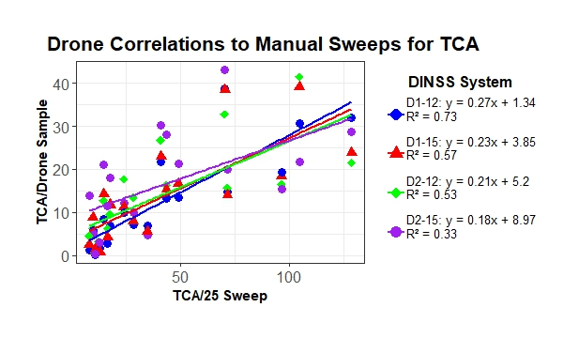
Figure 1: Correlation between DINSS configurations and a manual sweep net for threecornered alfalfa hoppers. Each point is the average of 4 sub-samples with each sampling method collected in Mississippi soybeans during 2023. The sweep net threshold for threecornered alfala hopper (TCA) adults and nymphs is 100/25 sweeps corresponding to a threshold between 25 and 28 TCA/ 50m DINSS sample with all configurations.

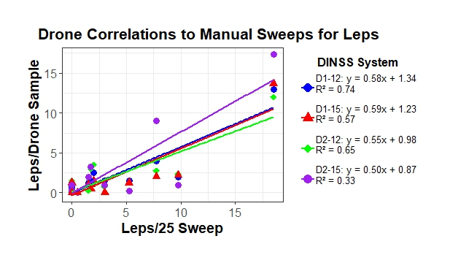
Figure 2: Correlations of DINSS samples to manual sweep net samples for lepidopteran pests. Each point is the average of 4 sub-samples with each sampling method collected in Mississippi soybeans during 2023. Because the sweep net threshold of 39/25 sweeps was not observed in any field, a drone threshold should not be projected from the data. With the data available, the regression lines and R-squared values reflect no statistical differences between DINSS systems.

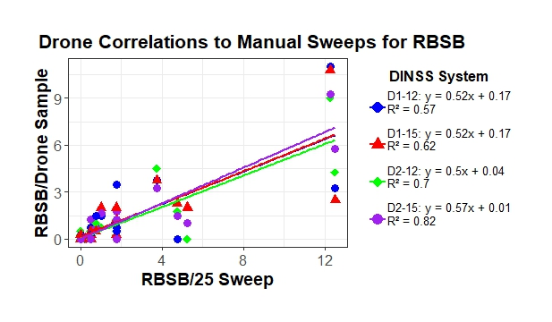
Figure 3: The correlations between redbanded stink bug samples collected using DINSS systems and a manual sweep net. Each point is the average of 4 sub-samples with each sampling method collected in Mississippi soybeans during 2023. The sweep net threshold for redbanded stink bugs is 4 bugs/ 25 sweeps which is comparable to between 2.0 and 2.3 bugs/50m for all DINSS systems.

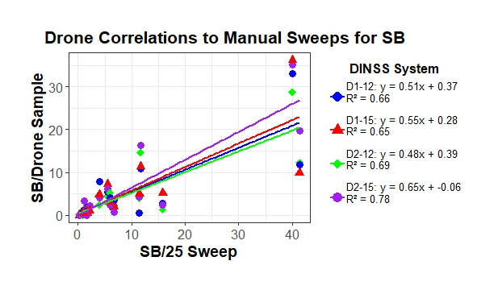
Figure 4: The correlations between stink bug samples collected using DINSS systems and a manual sweep net. Each point is the average of 4 sub-samples with each sampling method collected in Mississippi soybeans during 2023. Red banded stink bugs were counted as 2.25 stink bugs to make the thresholds equivalent for all stink bug species. The slope, formulas and r-squared values are not statisical different, and where the current threshold for stink bugs sampled with a sweep net is 9 bugs/25 sweeps, the DINSS threshold is between 4.7 and 5.9 bugs/50 m for all configurations.

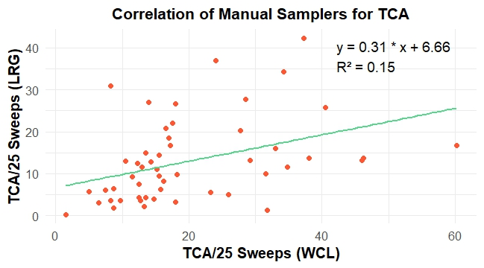
Figure 5: Relationship between sweep net samples of three-cornered alfalfa hoppers collected manually by two samplers (LRG and WCL) in Mississippi soybean fields during 2024. Each point represents the mean of 4 25-sweep samples collected by each sampler in the same field at the same time.

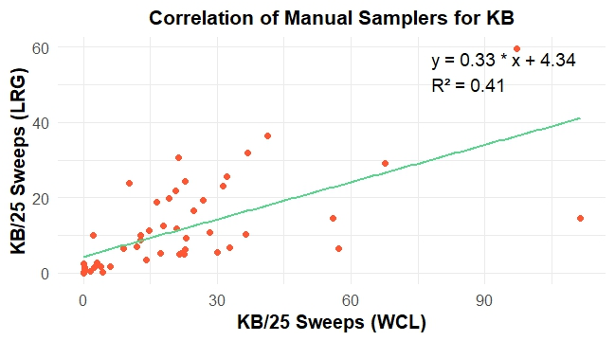
Figure 6: Relationship between sweep net samples of kudzu bug adults and nymphs collected manually by two samplers (LRG and WCL) in Mississippi soybean fields during 2024. Each point represents the mean of 4 25-sweep samples collected by each sampler in the same field at the same time.
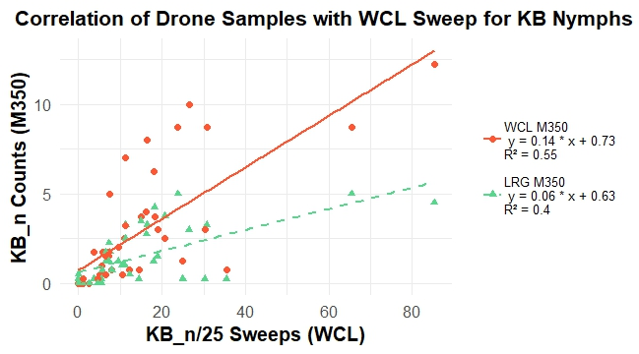
Figure 7: Relationship between DINSS samples of kudzu bug nymphs collected by two pilots (LRG (green data) and WCL (orange data)) in comparison to manual sweep net samples collected by WCL in Mississippi soybean fields during 2024. Each point represents the mean of 4 samples collected by each pilot in the same field at the same time compared to mean of 4 samples collected with a manual sweep net in the same field at the same time.
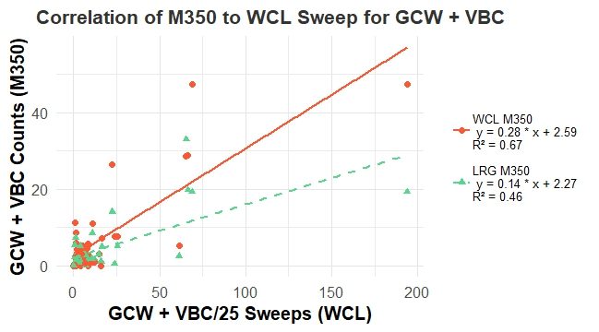
Figure 8: Relationship between DINSS samples of green cloverworm + velvetbean caterpillar larvae collected by two pilots (LRG (green data) and WCL (orange data)) in comparison to manual sweep net samples collected by WCL in Mississippi soybean fields during 2024. Each point represents the mean of 4 samples collected by each pilot in the same field at the same time compared to mean of 4 samples collected with a manual sweep net in the same field at the same time.
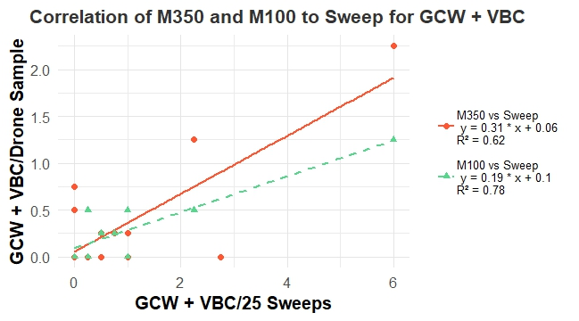
Figure 9: Relationship between DINSS samples of green cloverworm + velvetbean caterpillar larvae collected using two UAV models (DJI M100 (green data) and DJI M350 RTK (orange data)) in comparison to manual sweep net samples collected by WCL in Mississippi soybean fields during 2024. Each point represents the mean of 4 samples collected by each system in the same field at the same time compared to mean of 4 samples collected with a manual sweep net in the same field at the same time.
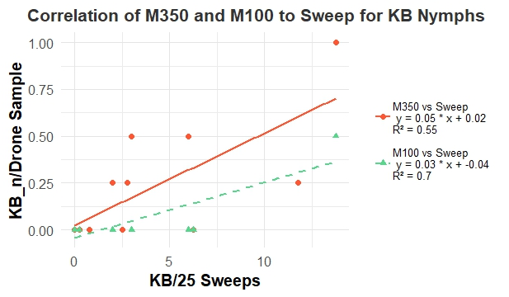
Figure 10: Relationship between DINSS samples of kudzu bug nymphs collected using two UAV models (DJI M100 (green data) and DJI M350 RTK (orange data)) in comparison to manual sweep net samples collected by WCL in Mississippi soybean fields during 2024. Each point represents the mean of 4 samples collected by each system in the same field at the same time compared to mean of 4 samples collected with a manual sweep net in the same field at the same time.

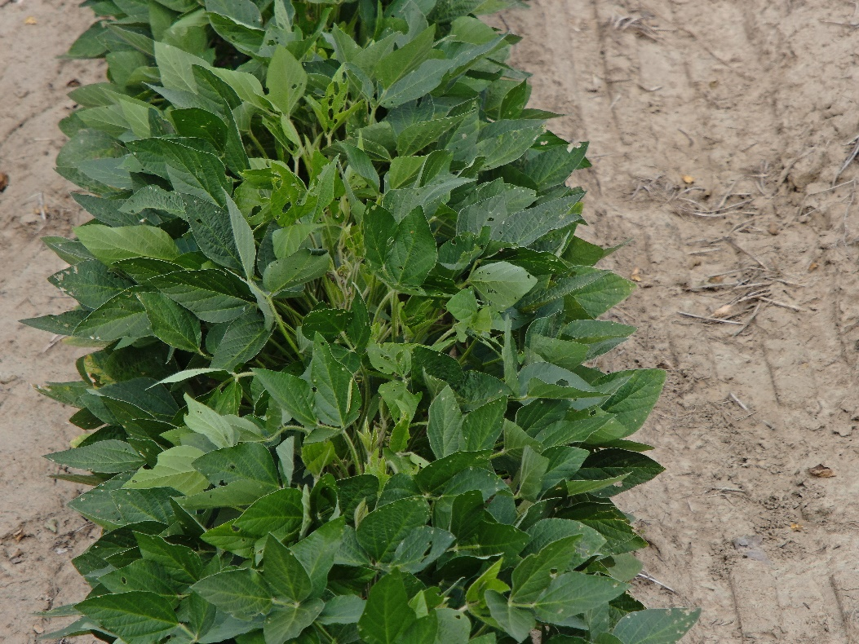
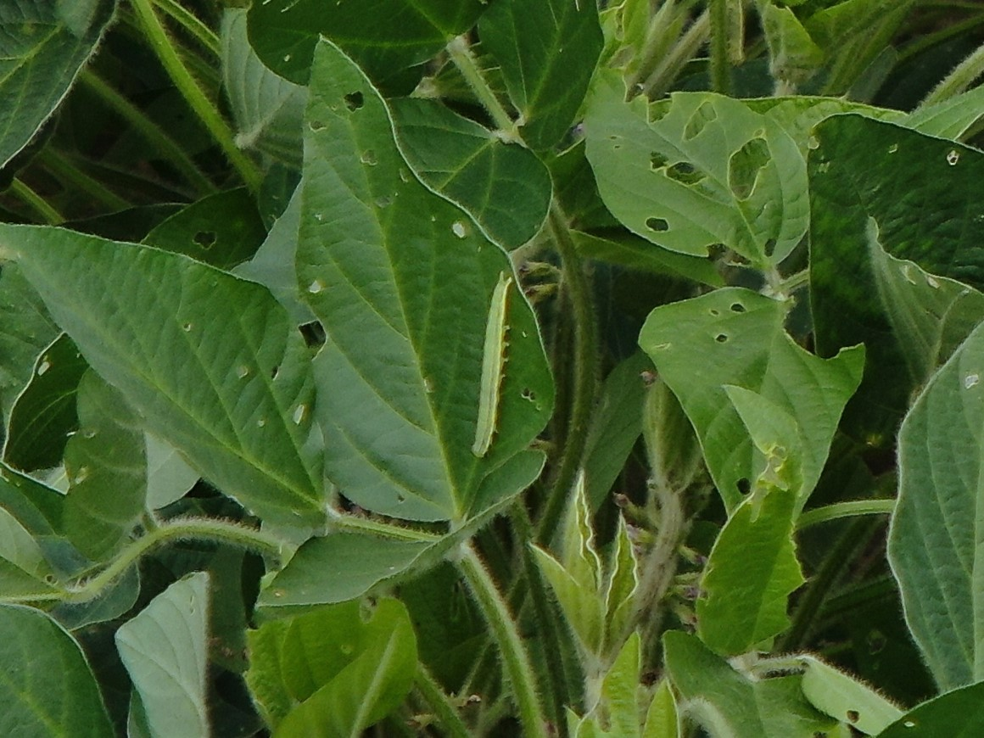
Figure 11. Sample photos of the defoliation imagery taken with the camera on the M350. Holes in leaves or actual insects were not difficult to find while using this UAV with a camera attached to it. The above photos are the same photo, the first is the original and the second is a zoomed in version, showing the high resolution of the images. The velvetbean caterpillar is identifiable when zoomed in.
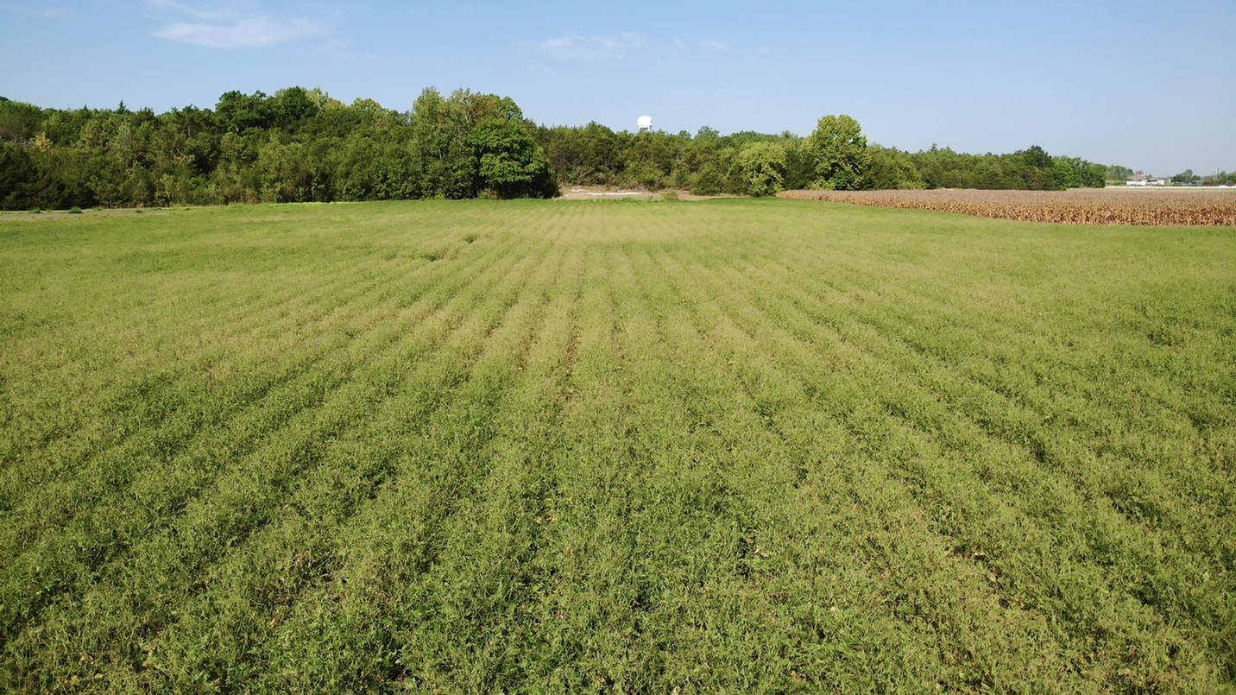
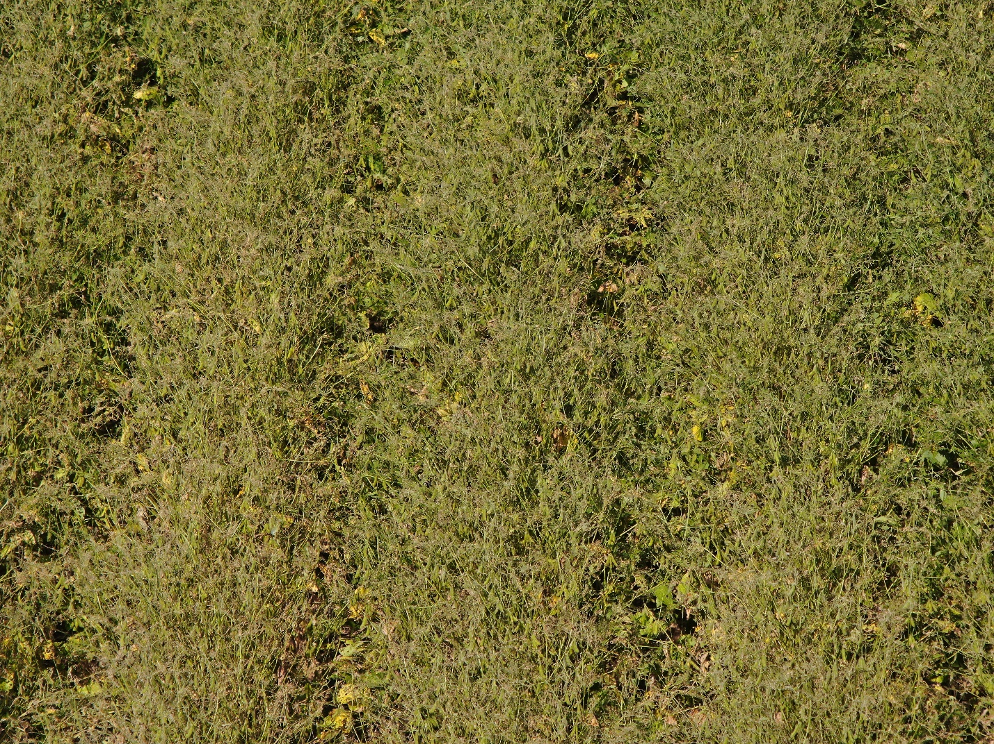
Figure 12. Images of soybean defoliation taken with the drone camera flying 10-15 feet above the canopy.
Table 1. Sampling times for manual sweep net and DINSS insect sampling methods. Time reported was the average of the total time required to collect 4 subsamples within a field.
Sampler/Pilot | Method/ DINSS System | Avg. Time (Minutes)
2023
WCL | Manual Sweep net | 4:05
WCL | D1-12 | 5:46
WCL | D1-15 | 5:50
WCL | D2-12 | 5:57
WCL | D2-15 | 5:46
2024
WCL | Manual Sweep Net | 4:07
WCL | DINSS with M350 | 6:15
WCL | DINSS with M100 | 7:11
JBW | Manual Sweep Net | 6:14
JBW | DINSS with M350 | 7:53
JBW | DINSS with M100 | 6:47
LRG | Manual Sweep Net | 5:01
LRG | DINSS with M350 | 7:30

